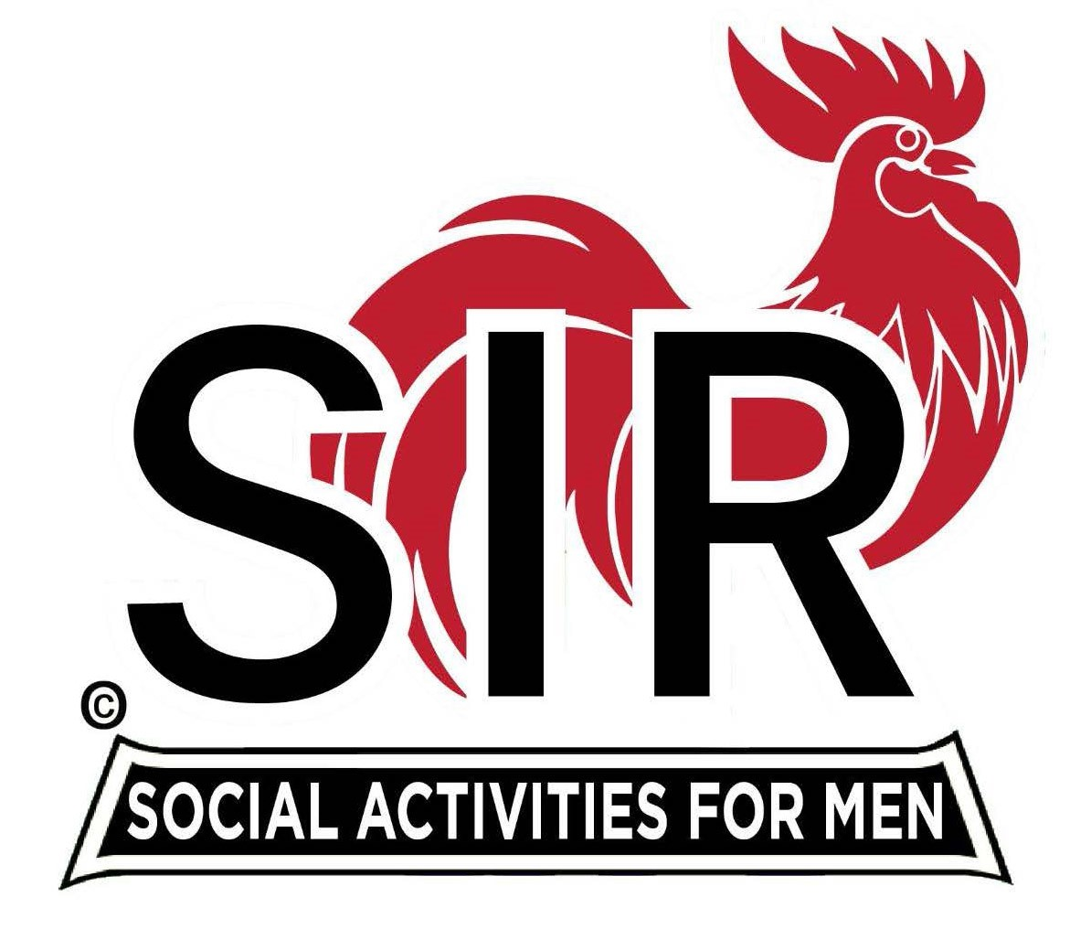

**Las Trampas Branch 116**

**BEC Meeting Agenda**

**June 16, 2025 - 9:15 AM at Boundary Oak**

***The Mission of SIR is to enhance the lives of our members through fun activities, events and luncheons while making friends for life.***

|  |  |
| --- | --- |
| **09:15** | **Call to order – Paul Russell**   * **Secretary - Dan Lawrence**    + **Confirm quorum**   + **Approval of April 21, 2025 BEC Meeting Minutes** |
| **09:20** | **Standing Reports**   * **Treasurer Report – Charlie Guthrie**   + **Treasury Report**   + **Luncheon Count** * **Big SIR Report – Paul Russell**   + **Branch Advisory Council – Carlos Xavier –** no update this month * **Membership – Phil Goff** * **RAMP Department Head Reports**   + **Recruitment – Jeff Johnson**   + **Activity Coordinator – Mike Ward**   + **Member Relations – Sam Beret** – no report this month   + **Publicity – Allan Farbman** |
| **9:45** | **Little SIR Updates – Brad Stribling**   * **Speaker Info – Today’s speaker – David Bushnell, short Bio** * **Birthday Boys – May and June** |
| **9:55** | **Updates & New Business**   * **Guests:**    + **Tom Mackinson – sponsored by Jim Tamulski**   + **Mike Sherman – sponsored by Jim Tamulski** * **Call for Questions** |
| **10:15** | **Adjourn:** – Next meeting, July 21, 2025   * **Lunch Preparations** |