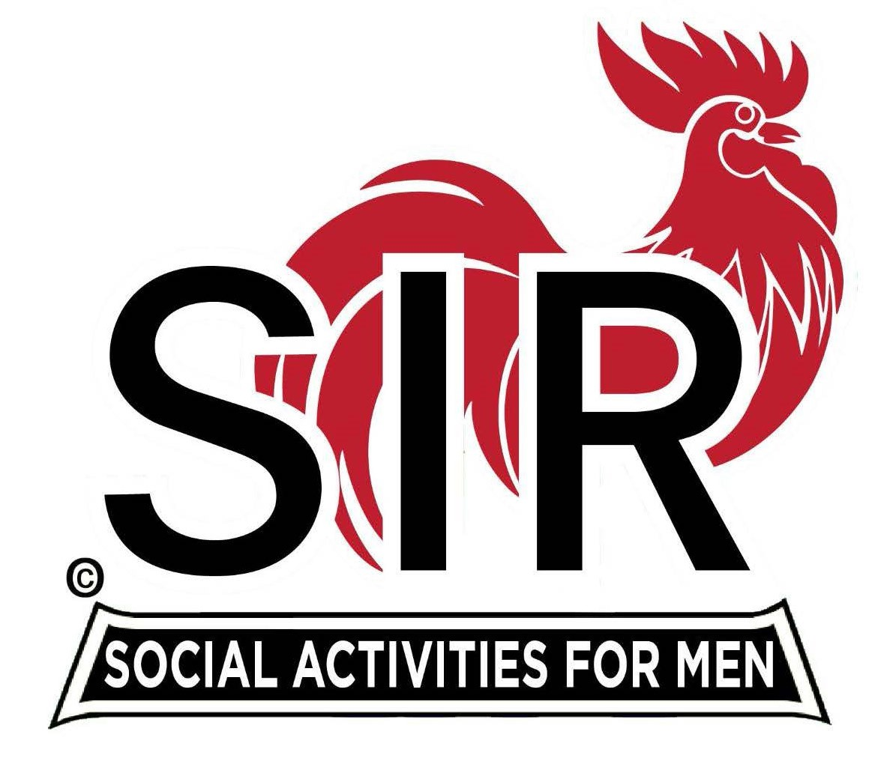

**Las Trampas Branch 116**

**BEC Meeting Agenda**

**April 21st, 2025, - 9:15 AM at Boundary Oak**

***The Mission of SIR is to enhance the lives of our members through fun activities, events and luncheons while making friends for life.***

|  |  |
| --- | --- |
| **09:15** | **Call to order – Brad Stribling**   * **Secretary - Dan Lawrence**    + **Confirm quorum**   + **Approval of March 17th, 2025, BEC Meeting Minutes** |
| **09:20** | **Standing Reports**   * **Treasurer Report – Charlie Guthrie**   + **Treasury Report**   + **Luncheon Count** * **Big SIR Report – Brad Stribling in behalf of Paul Russell** * **Branch Advisory Council – Carlos Xavier** * **Membership – Phil Goff** * **RAMP Department Head Reports**   + **Recruitment – Jeff Johnson**   + **Activity Coordinator – Mike Ward**   + **Member Relations – Sam Beret**   + **Publicity – Allan Farbman** |
| **9:45** | **Little SIR Updates – Brad Stribling**   * **Speaker Info – Today’s speaker – Capt. Bill Nelson, short Bio** * **Birthday Boys – April** |
| **9:55** | **Updates & New Business**   * **Guests:**    + **Brad’s guests**   + **Paul Russell’s guests (by Jeff J.)** * **Call for Questions** |
| **10:15** | **Adjourn:** – Next meeting, June 16th, 2025   * **Lunch Preparations** |