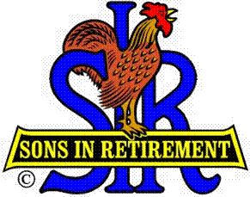
Las Trampas Branch 116
Luncheon Meeting Agenda
October 21, 2024, 11:30 AM

10:30 Social Hour
Greeters – Paul Ramacciotti, Joe Datzman
Treasurer Table – Charlie Guthrie, Al Satake
Name Tags Table – Dennis Snarr
Raffle Table – Ben Bryce, Bob Huck

11:25 Five Minute Call
11:30 Call to order – Big SIR
Pledge of Allegiance – Big SIR
Invocation/Remembrance – Dave Williams

11:35 Storyteller – Mac McLoughlin
11:40 Big SIR Report – Alan Pope

Introduce Guests – Don Campbell, Tony Moraga
Welcome Attendance of Speaker – Nik Dehejia
Holiday Party – December 17, Flyers are on tables
Thanks to Past Big SIRS - Roger Craig (’23) Fred Wachowicz (’22) Sam Beret (’21) Michael Barrington (’20), Jerry Hicks (’19) Marty Katz (’18) Paul Ramacciotti (’17) Jim Barstow (’16) Bob Donohue (’15) Phil Goff (’14) Neil Schmidt (’12) Ron Armijo (’11) Jed Daniel (’10) Art Donaldson (’08)

11:46 Activity Reports - Mike Ward: Reports by certain Activity Chairmen
12:00 Lunch
12:25 Introduce Speaker – Little SIR
12:27 Speaker – Nik Dehejia, CEO of Oakland Zoo
12:52 Speaker Thank You – Big SIR
12:54 Raffle Drawing – Bob Huck, Ben Bryce
Birthday Drawing – Little SIR
13:00 Sing Happy Birthday – Dave Williams
Sing God Bless America – Dave Williams
13:04 Adjourn; Next meeting, November 18, 2024

