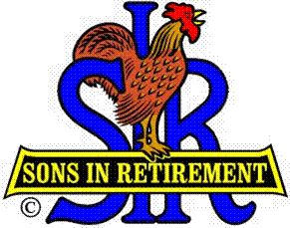
Las Trampas Branch 116
Luncheon Meeting Agenda
August 19, 2024, 11:30 AM

10:30 Social Hour
Greeters – Paul Ramacciotti
New Member Orientation – Dave Williams
11:25 Five Minute Call
11:30 Call to order – Big SIR
Pledge of Allegiance – Big SIR
Invocation–

11:35 Storyteller –
11:42 Comment sheets – Big SIR, Sam Beret

Introduce Attendance of Speaker – Jon Kaplan

Thanks to Speaker Committee – Paul Russell, Paul Freitas, Allan Farbman

11:46 Activity Reports - Mike Ward: Reports by _______________________
12:00 Lunch
12:20 Introduce Speaker – Little SIR
12:22 Speaker – Jon Kaplan, Administrative Executive Officer, Contra Costa County Search and Rescue
12:52 Speaker Thank You – Big SIR
12:54 Raffle Drawing – Bob Huck, Ben Bryce
Birthday Drawing – Little SIR
13:00 Sing Happy Birthday
Sing God Bless America
13:03 Closing Remarks – Big SIR
13:04 Adjourn; Next meeting, September 16, 2024

