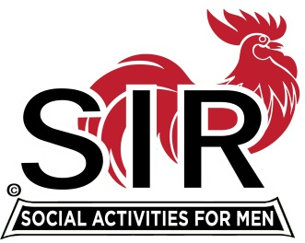
Las Trampas Branch 116
Special BEC Meeting Agenda
April 27, 2021, 8:30 AM
The Mission of SIR is to enhance the lives of our members through fun activities, events and luncheons – while making friends for life.

8:30 am Call to order; Secretary confirm a quorum

8:35 Big SIR Report – Sam Beret

- State SIR Directives
- Directors’ Liability Coverage
- Discussion: Next Steps for Branch Activities
a- outdoor activities that are currently open
b- for “indoor” activities that may be opened in the coming months

9:00 Branch website - Neil Schmidt, Phil Goff

9:30 Adjourn; Next BEC Meeting, May 17, 2021

Join Zoom Meeting Weblink
https://us02web.zoom.us/j/85332344422
Meeting ID: 853 3234 4422
Passcode: 612956
Dial by home phone: (669) 900-9128

