 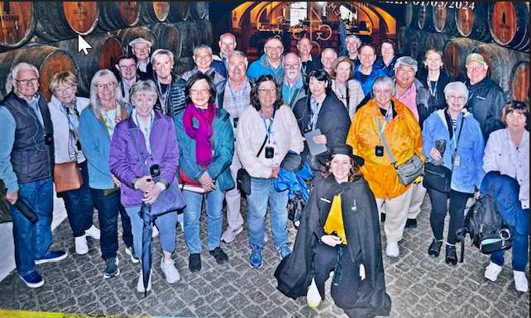 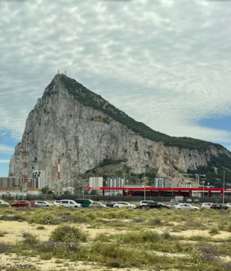

**TRAVEL**

**Glenn Breslin**

**GOOD NEWS !!!** Based upon both the SIR Multi-Branch travel questionnaire results and the related member interview input, these travel destinations have been chosen for future SIR Travel in priority order.

**SIR Travel Destinations**

1. Australia/New Zealand: [LINK HERE](https://www.gct.com/trips/land-tours/south-pacific/australia-and-new-zealand/2021/itineraries) for more information
2. Vietnam: [LINK HERE](https://www.oattravel.com/trips/land-adventures/asia/inside-vietnam/2021/itineraries) for more information
3. Japan/Korea: [LINK HERE](https://www.oattravel.com/trips/land-adventures/asia/south-korea-and-japan-temples-shrines-and-seaside-treasures/2021/itineraries) for more information

All these trips will be orchestrated by Overseas Adventure Travel (OAT). The next step is to reach out to pertaining SIR Members to choose the start and end travel dates for each above trip.

**SIR Travel Plan:**

* **Done** September – Obtained SIR Travel Questionnaire results from SIR146 and other SIR Branch members. Narrowed down to 5 In-Common Destinations.
* **Done** October - Interviewed everyone that chose the 5 In-Common Destinations.
* **Done** November – 3 SIR Travel Destinations selected from the above 5 In-Common Destination. See above numbered list.
* To Do December – Work with SIRs that choose these future SIR Travel Destinations to pick the start and end travel dates for each above numbered trip.
* To Do December - Publicize these trips to SIR146 and other SIR groups

**Travel Quotes:**

“A journey well shared is a journey well enjoyed.”

“There is an unspoken bond you create with the friends you travel with.”

“A journey is best measured in friends rather than miles.”

Glenn Breslin

SIR146 Travel Chair

[glennbreslin@gmail.com](mailto:glennbreslin@gmail.com)

925-788-6520