
STATE VICE PRESIDENT- Sir Lee Lamp, lel4355@yahoo.com, (925) 324-0838

Bill Crocker, 530-673-8982-ATTENDANCE
Gary Kim, 916-205-7427- e-BULLETIN
Barry Greathouse 530-415-9175-PROGRAM
Dennis Dempsey, 530-487-3830-SUNSHINE

A nonprofit public benefit organization for retired men devoted to the promotion of independence and dignity of retirement.
Meets the first Monday of every month at 11:45 in the Plaza Room, Julie Drive, Yuba City
Maintenance of membership requires regular attendance. Branch Executive Committee (BEC) meeting follows the monthly luncheon at 1:40 p.m.

STATE PRESIDENT- Sir Rich Carlston, rich.carlston@icloud.com, 952-324-0838
AREA 2 DIRECTOR – Mark Stuart, mss95678@hotmail.com, (916) 218-2287
BIG SIR- Bijan Parhizgar 530-301-8740
LITTLE SIR- Barry Greathouse 530-415-9175
SECRETARY- Steve Marshall
ASST. SECRETARY- Bill Craig, 530-763-5476
TREASURER-Brad Johnson, 530-632-7943
ASST. TREASURER-Guy Rector, 530-674-1236

NUMBER TWELVE
VOLUME FIFTY-TWO

PEACH BOWL BRANCH 45
INCORPORATED
SIR Branch 45 Website: branch45.sirinc2.org
BOARD OF DIRECTORS
Bill Crocker  530 673-8982 | Ed Kennedy  530 673-9731 | Doug Parker  530 671-9133 | Tom Bethards  530 632-6751 | Tom Thompson  530 751-9225 | J.P. Hill  530 632-8246

DECEMBER 2024

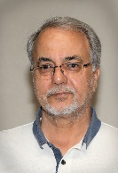
BIG SIR MESSAGE
Bijan Parhizgar, 530-301-8740
bthere4asap@yahoo.com

Dear Sirs,
As your Big Sir, I look forward to seeing you all again on Monday, December 2, 2024.
During the past couple of years, As I visited different eateries, markets, and other establishments, much to my joy, I noticed more and more friendly faces and people greeting or nodding at me warmly. It makes me feel like more of a member of our community. I strongly believe it has much to do with me serving you good folks as your Little Sir and Big Sir. For that reason, I say being a member of Sirs has been one of the best assignments during my 38-year career. It’s been fun, exciting, and a great learning experience. I very much like to thank the BEC and Executive Committee for all their support and backup to help me succeed in this assignment.
Christmas Dinner and Dance will be on Thursday, December 12th. See below for the menu and other details. As of last month, we sold the required number of tickets. I am very excited to see more of you jumping in, as I believe it is going to be a great party and get-together. We will have Christmas dinner tickets available for sale again, at our December luncheon.
As far as attendance, this year has been a good year so far, however, please keep in mind to invite/ask a friend or two to our December luncheon.
That is all for now and see you soon.
Sincerely Yours,
Bijan Parhizgar
Big Sir
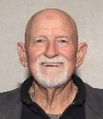
LITTLE SIR MESSAGE
Barry Greathouse, 530-415-9175
PPABARRY62@GMAIL.COM


Guest Speaker for December
Gary Kim
Twin Cities Rod & Gun Club
(916) 205-7427, GaryKim@Comcast.Net

BIRTHDAYS FOR DECEMBER

  Neal Brookman | 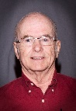  Earl Cortner | 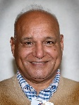  Mo Dosanjh | 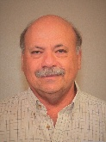  Dave Goldwyn | 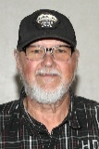  Perry Hayden | 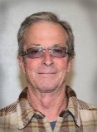  Dale Hoag
  Lee Kirchner | 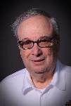  Tony Kurlan | 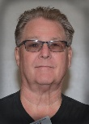  Richard Laird |   Robbie Merwin | 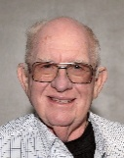  Larry Munger | 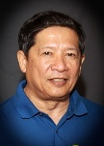  Noli Pabalan
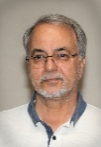  Bijan Parhizgar | 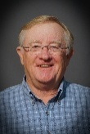  Mike Pederson | 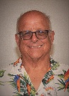  Bill Shaul | 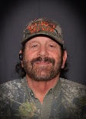  Mel Verzi | 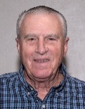  Tom Walther

New Members
Jonathan Dickman 530-359-8902
Mike Mitchell 530-315-4979
Paul Tice 530-701-0402
Glenn Jaschke 530-713-1942
Rich Hackney 530-713-5157

Committee Chairs
Attendance: Bill Crocker
Asst. Attendance: Mike Gyorfi
Badges: Bill Smith
Bicycling: Bill Craig
Asst. Bicycling: Gilbert Corchado
Bocce Ball: Carey Saunders
Asst. Bocce Ball:
Bowling: Ray Buttacavoli
Asst. Bowling: Jeff Brockman
Card Guy:
Asst. Card Guy: Bob Penix
Cashier: Fred Preston
Asst. Cashier: Darel Abbott
Chaplain:
Asst. Chaplain: Dieter Rex
Fine Dining: Tom Bethards
Fishing: Pat Dilling
Asst. Fishing:
Golf: Dennis Dempsey
Asst. Golf: Peter Brennan
Historian: Bill Crocker
Membership: Bill Crocker
Photography: Bob Engen
Photographer: Richard Grant
Pool: Ruben Gomez
Asst. Pool: Bob Penix
Roster: Dave Goldwyn
Asst. Roster: Bill Crocker
Sunshine: Dennis Dempsey
Asst. Sunshine:
Website: Bill Crocker
Asst. Website: Gary Kim

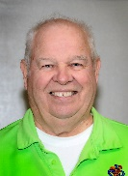

DINING OUT

Tom Bethards, 530 632-6751
Assistant, Phone

2025 will be a new year of dining activities.

Tom Bethards, Peachtree Dining Out Activity Coordinator. chevyman61@comcast.net is my email or call me at 530 632-6751. Bon appetite.

WHEN WE LAST MET
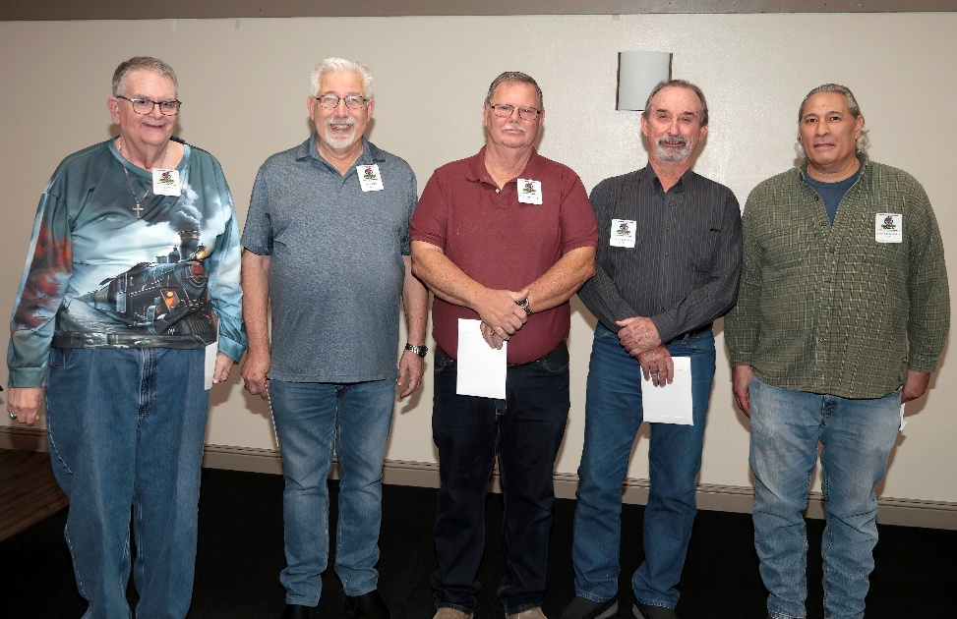
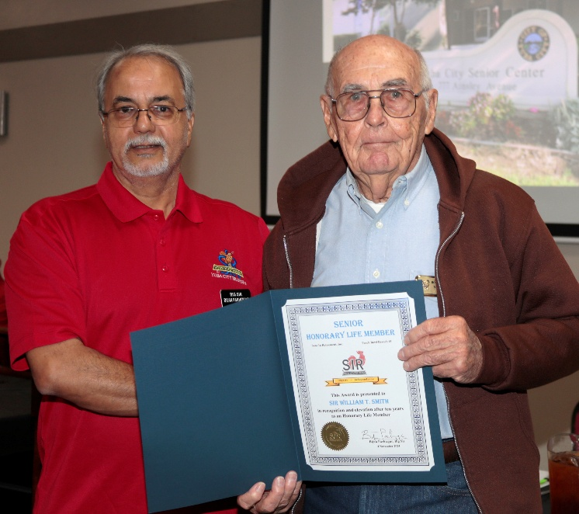
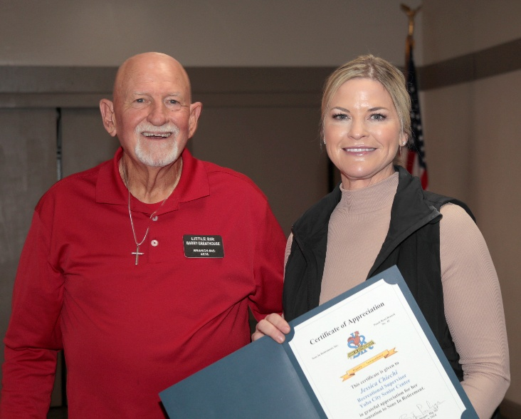
New Members: Rich Hackney, Paul Tice, Mike Mitchell,
Glenn Jaschke & Jonathan Dickman

Bill Smith, Honorary Life Member
Guest Speaker Jessica Chiechi

YUBA CITY/MARYSVILLE BOWLING

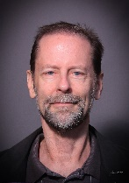
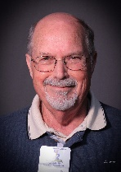
Ray Buttacavoli, 530-329-2038
Jeff Brockman, 530-755-0746

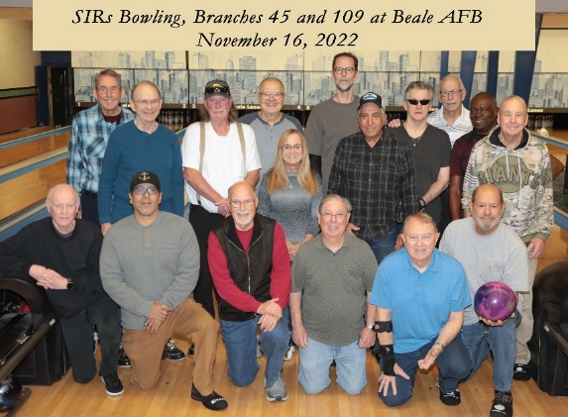

We finished our ’23 ~ ’24 bowling season on July 31ST, and I thought it might be interesting to provide you with a very brief summary of the season. We paid Beale Lanes over $8,000 in bowling fees, and we returned to our bowlers over $7,400 in weekly awards. Then finally we had two sweepers during the year that paid out about $850 to our bowlers with some outstanding results.
We have now started our new season which will run until July 30, 2025. In addition, we recently had 9 of our bowlers plus 3 guests compete in a bowling tournament in Reno. Two of our 4-person teams took 1ST Place in their respective divisions. The team of Dan Moreno & Larry Herrera (Branch 109) and Stan Gryczko and your truly each earned $80 for their efforts. The team of Jeff Brockman & Harvey Robinson and their guest each earned $74.50 for their efforts. Then in the Doubles competition, the team of Larry Herrera & Stan Gryczko placed third in their division, each earning an additional $49; and the team of Jeff Brockman & Peggy McCarty placed 4TH in their division, each earning an additional $47. In the Singles competition, two of our guests Lorraine Williams and Michelle Dunn placed 1ST and 3RD respectively in the Ladies Division. That wasn’t the end of the awards, with Jeff Brockman and Larry Herrera each finishing 3RD in divisions for All Events. But the big winner in All Events was Lorraine Williams who placed 1ST in the Ladies Division. (All Events is a combination of the scores from each of the three events.)
We continue to bowl every Wednesday at 11:00 AM. All are still welcome to bowl with us. But if you have not bowled with us since we moved to Beale AFB, it will be necessary to contact me so that we can start the paperwork for the Guest Pass, that is unless you have a valid military ID. You can contact me at the phone number above or via email at rdb0416@comcast.net if you have any questions.

SLOW TROLLERS
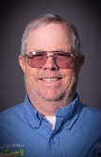
Pat Dilling, 530-218-0641

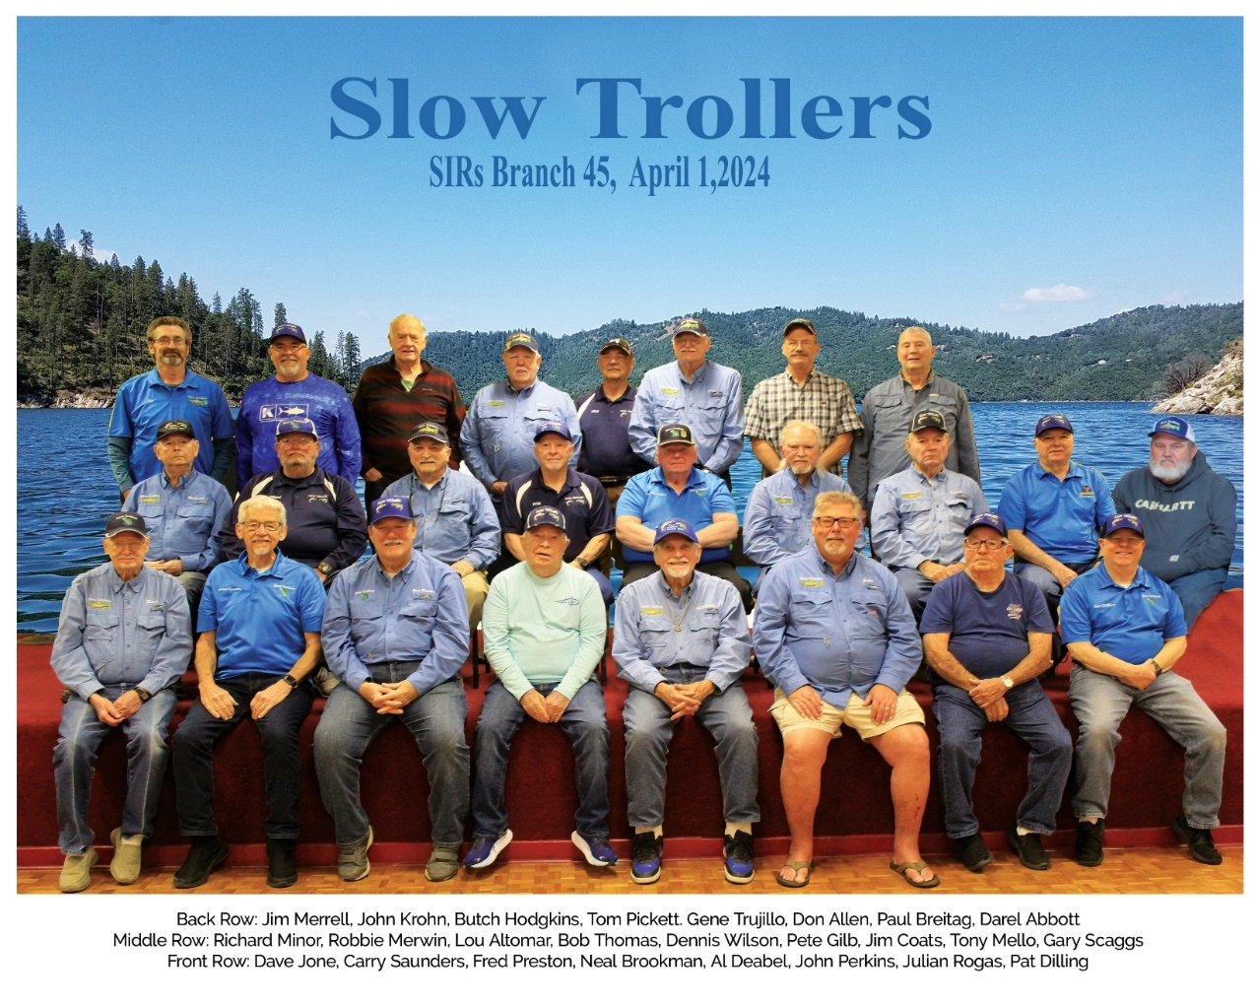

The Slow Trollers Fishing Club meets at the Yuba City Moose Lodge, 205 S Walton, Yuba City at 9 am on the same day as the SIRs meeting. Come a little early for coffee and donuts.
The Slow Trollers had a good turnout at Lake Oroville on Aug 15 with 15 Slow Trollers fishing from 7 boats. The report is that everyone caught some fish with 9 people choosing to bring some to the scales. Robbie Merwin continues his hot streak with 5 nice bass weighing 11 pounds 1 ounce. Carey Saunders had the big fish at 2 pounds 11 ounces. Tom Picket caught the only salmon, and it was a dandy weighing in at 4 pounds and 6 ounces.
Because of the Labor Day Holiday, our next meeting is not until Monday Sep 9th. Hope to see everyone there as we will make final plans for our annual picnic on September 26th. Our September fishing event is a fun day at the Oroville Afterbay.

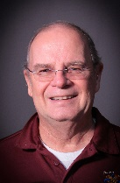
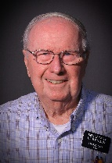
PHOTOGRAPHY
Bob Engen, 530-845-8360
Richard Grant, 530-713-1919

The SIR’s Photo Club meetings are held at the Dancing Tomato. It is located at Highway 20 and Walton Ave., in Yuba City. We meet there regularly at 9:00 AM on the 2nd Tuesday of each month. Our December meeting is on the 10th. We have breakfast and a great time sharing photos and talking about all things in photography. We occasionally go on field trips as opportunities arise. All are welcome.
Photo of the Month by Michael Walsh 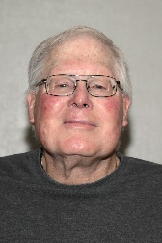
Venice, Italy
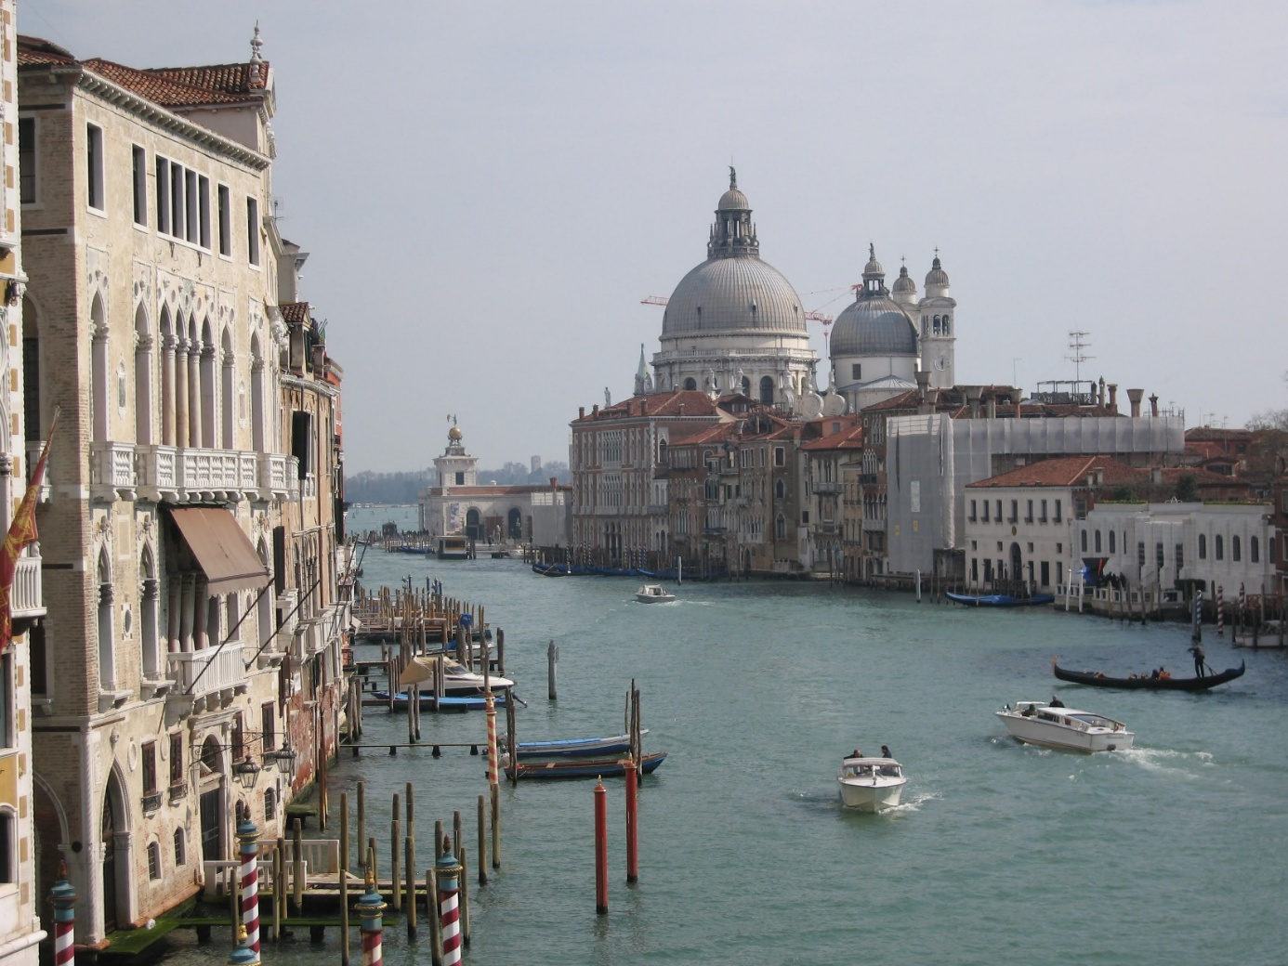
A beautiful canal scene.

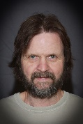
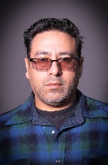
POOL
Ruben Gomez, 530-743-0477
Bob Penix, 530-790-0723

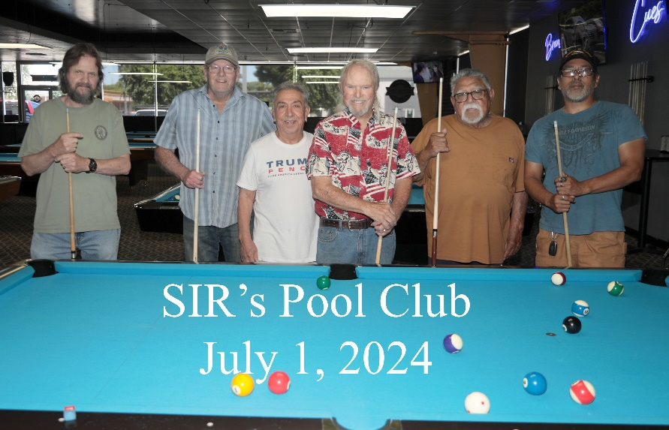

Mondays at 2:00 PM. Play at Gold Rush Billiards next to Papa Murphy’s Pizza on Gray Ave. Even if you never played pool, come on out and learn. You’ll enjoy it.

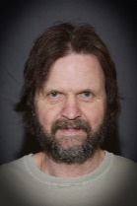
CARDS

Bob Penix, 530-790-0723

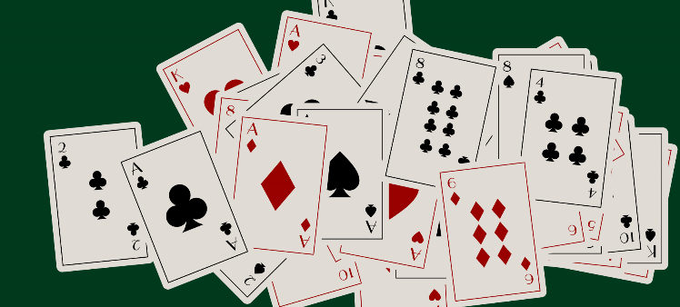

Wednesdays 12:00-4:00. Played at different players’ houses each week.

BICYCLING
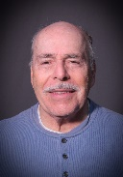
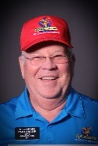
Bill Craig, 530-763-5476
Gilbert Corchado, 530-434-6525
Whether it’s a couple of us or a dozen, the group has so much fun together that we want to share our joy with you. We are noticed in the community and meet new people. Spouses and guests are always welcome. We currently ride as a SIR activity on Fridays from Regency Park in north Yuba City, Please call Bill Craig, 530-592-6592, or Gilbert Corchado, 530-845-2854, to get updates on ride times.
Try it, you’ll like it!
📸 Look at this post on Facebook SIR Bicycle Club on Facebook

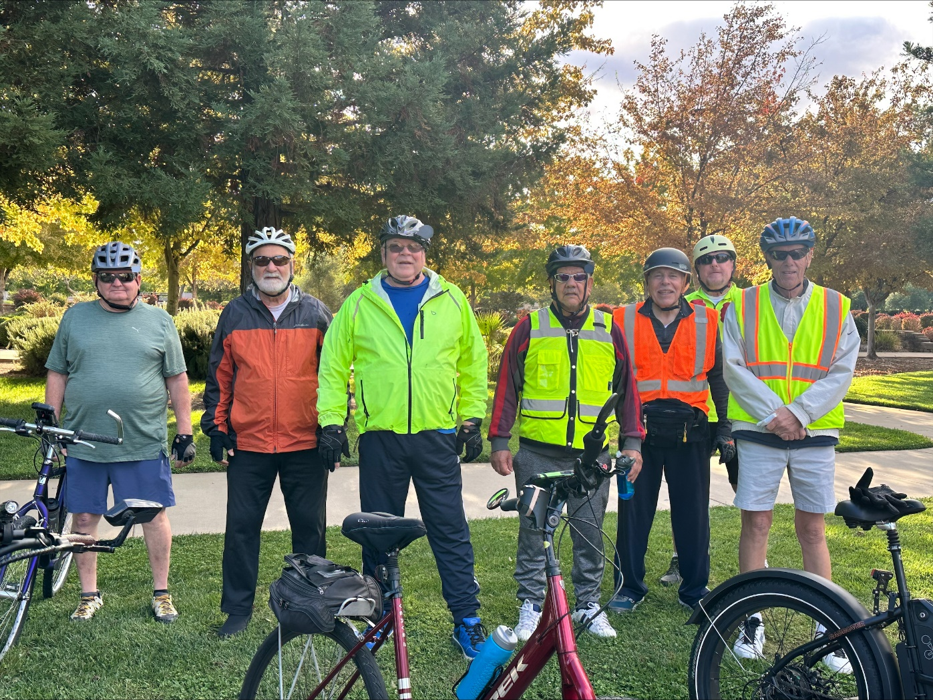

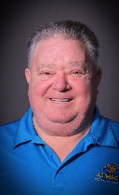
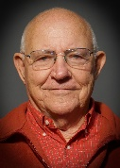
GOLF REPORT

Dennis Dempsey, 530 487-3830
Pete Brennan, 530 674-7234
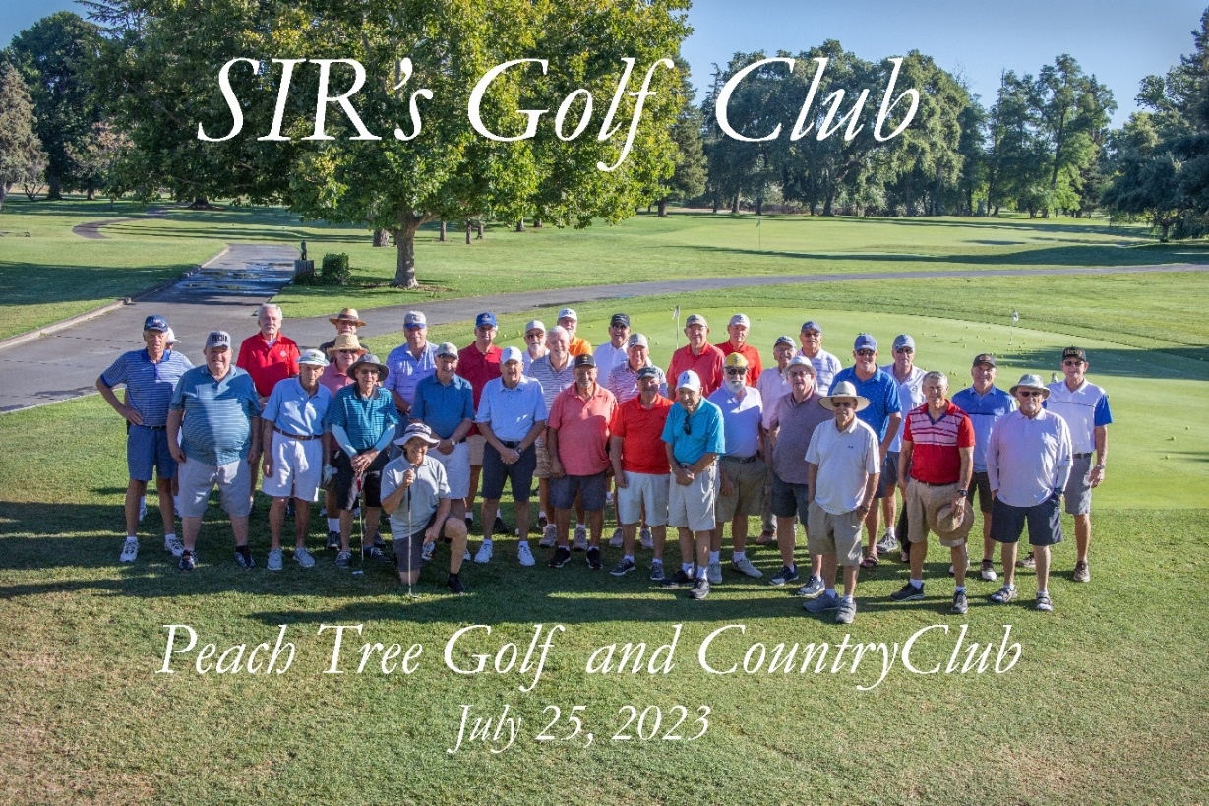
Thank you for the good season and I hope everyone is happy. I just want to remind you that NCGA dues are due and should be paid as soon as possible so it doesn't cost you more later. Dues are 59.00 and can be paid for at the meeting on December 2 or at our first breakfast on December 6 at the Moose Lodge at 8 AM. We want to make sure that dues are paid by our organization on time and we don't have to charge more.
Here are some important dates to remind you
December 2nd SIR meeting
December 3rd Yocha De He CANCELLED
December 6 All players breakfast at Moose Lodge 8 am 10.00
Again, thank you all for your support and we will have another meeting in February to hand out new schedules and talk about the coming season. God Bless and Merry XMAS and Happy New Year to all your families.

Dennis Dempsey
Golf President
Sir Branch 45
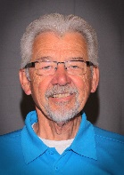
BOCCE BALL

Carey Saunders, 530-632-1859

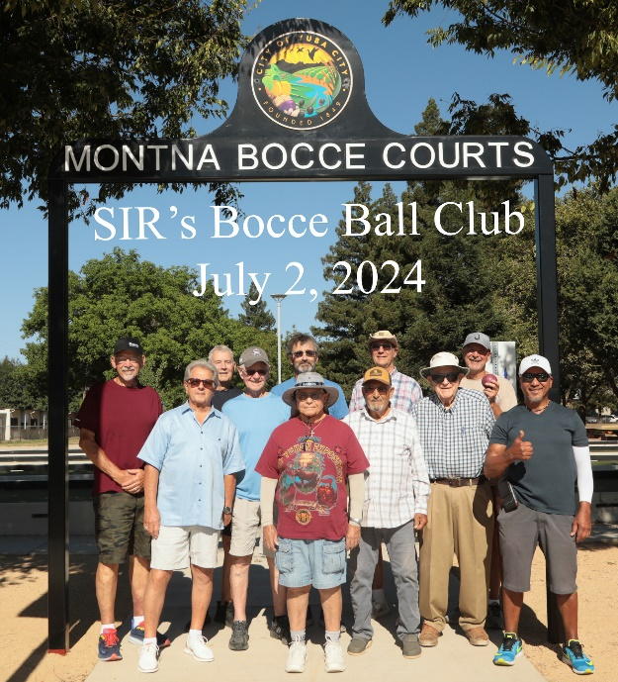
Tuesdays 10:00. Played at Kingwood Park on Gray Ave. We are looking for more participation so that we can enter tournaments with other branches.

TREASURER’S REPORT
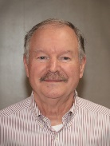
Brad Johnson, 530-632-7943

The ending October balance is: $7,422.62
The ending November balance is: $8,186.70

