BlueGolf Tour – See tournament results, hole by hole scoring, and more
Login to BlueGolf and explore results of completed tournaments and details of future competitions.
Login to Bluegolf.com on your computer. (So far the BlueGolf phone app is not very good. If you use your phone, access BlueGolf.com through your phone’s internet browser instead.)
Your login ID is your email address. The first time you login you will be sent a 4-digit code to your email. Enter that code into the login screen.
You have the option of creating a password that you can use every time you login or you can skip creating a password and just request a 4-digit code for each subsequent login.
Once login is complete you will be at your BlueGolf Home Page.
Home Page:
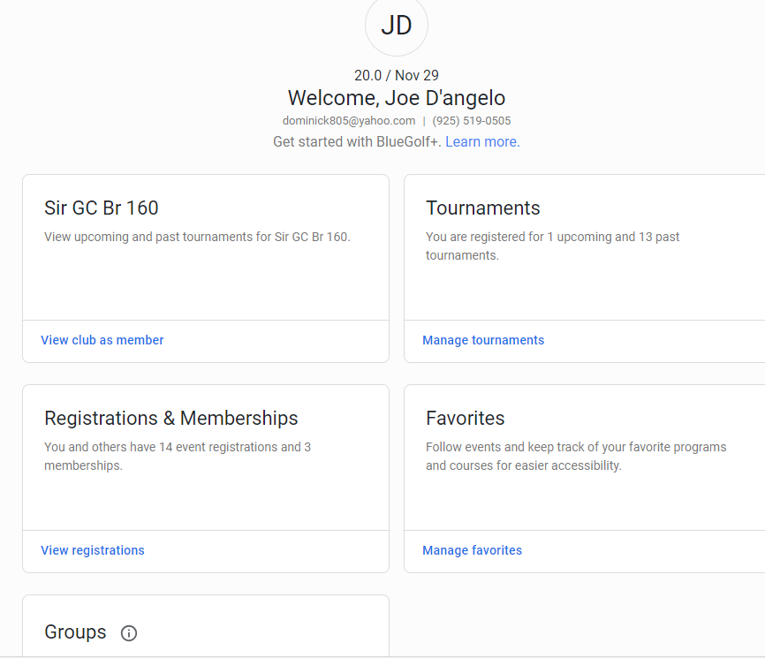
Click on Home Page links to explore.

Tournaments:
Click on the Manage Tournaments link our Tournaments “card”.
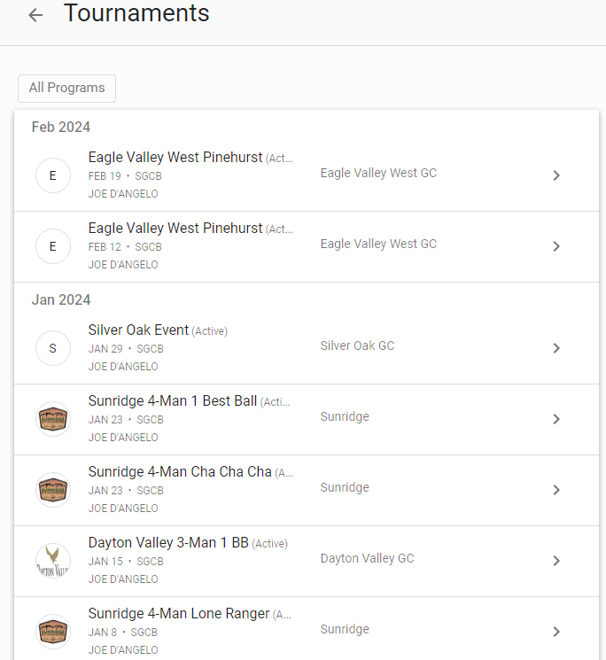

Click on a completed Tournament (e.g. Silver Oak Lone Ranger). View the Leaderboard. Click on the drop down box in the upper left to see other contests such as KPs:
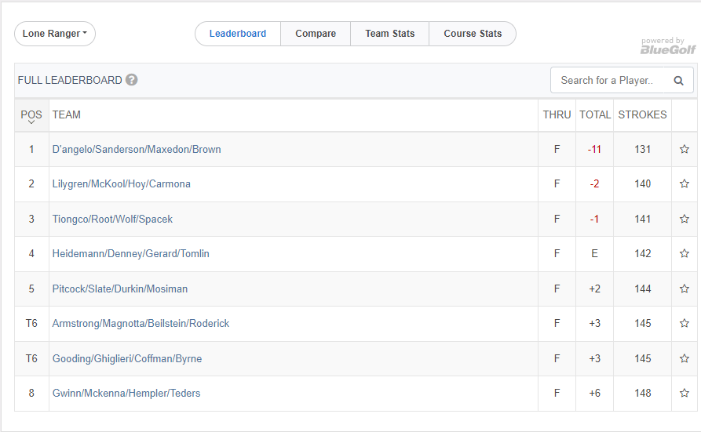

Click on your team name:
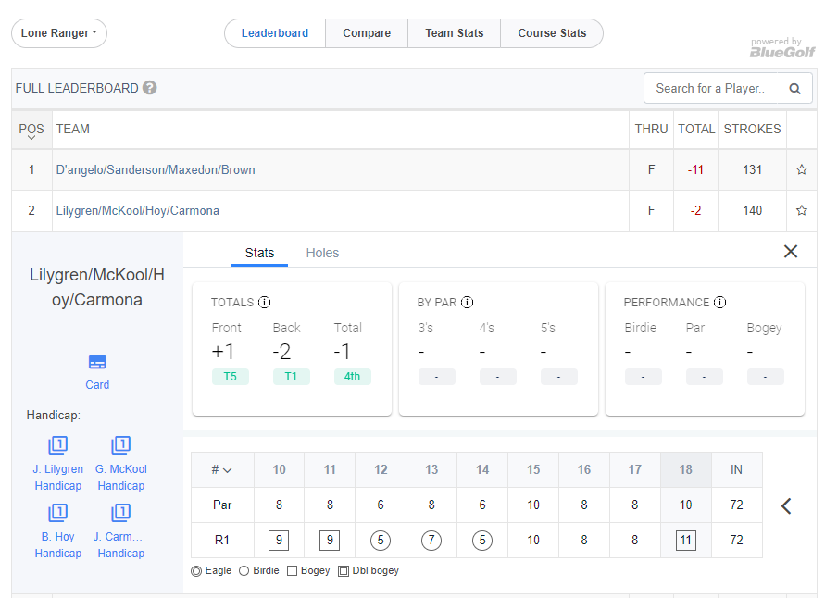
Explore the Team results.

Click on the Card Icon to view your team’s scorecard.:
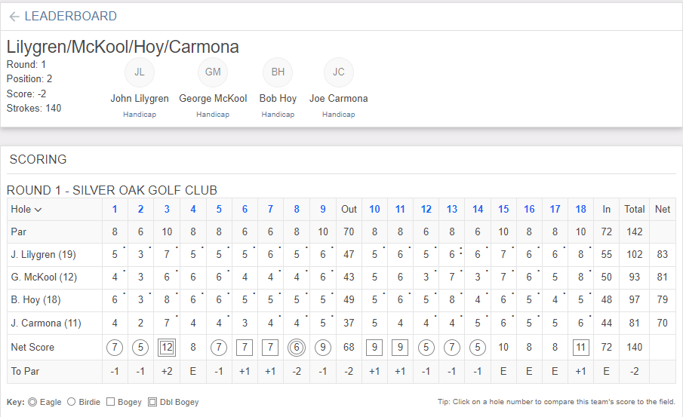
Lilygren is the Lone Ranger on hole #1, McKool on #2, and so forth. See how BlueGolf used John’s net 4 and George’s net 3 on hole #1 for a combined score of 7 or -1 for the hole. BlueGolf used George’s net/gross 3 and Bob’s net 2 for a combined score of 5 or -1 for the second hole. BlueGolf calculates a combined net score on each hole and a total for the full 18 holes.
Click on other teams to see their results.

Click on the Teams card to see your competing teams and their Index/Course Handicap:
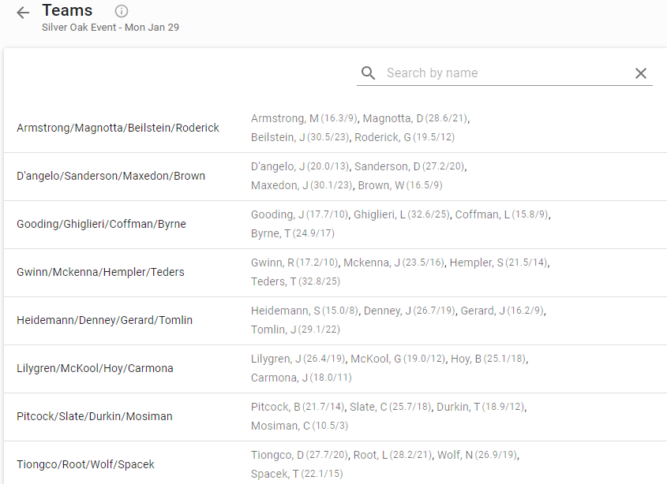
Click around and explore!

