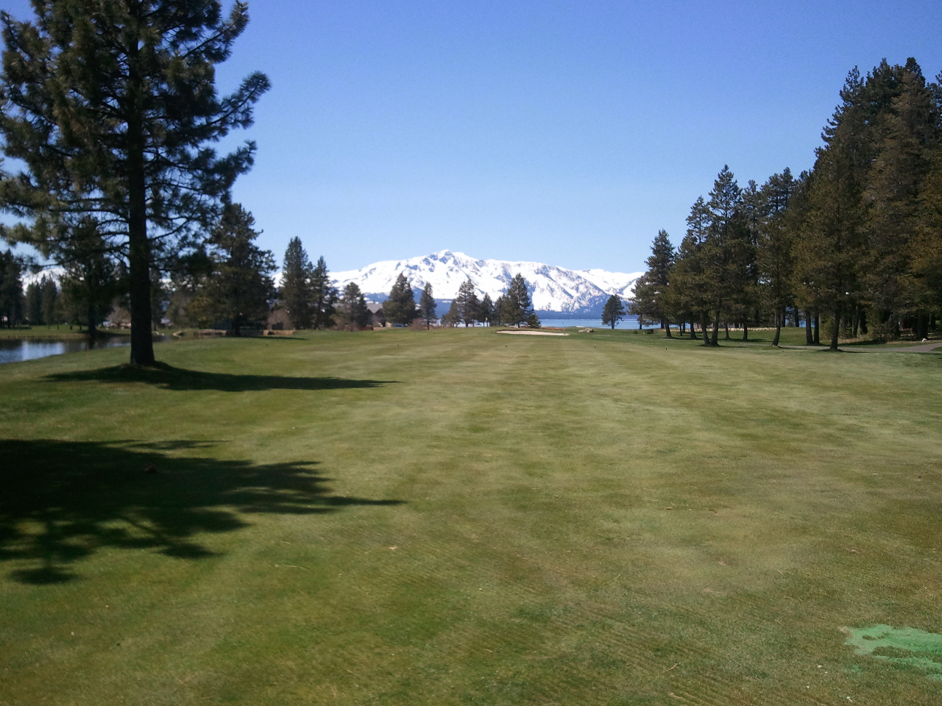** ***“The SIR” ~ LAKE TAHOE BRANCH 160 ~*** **

***CHARTERED APRIL 22, 1991***

**MEMBERSHIIP OPEN TO MEN REGARDLESS OF AGE, RACE, COLOR, OR RELIGION**

**GETTING TOGETHER FOR LUNCH AND ENJOYING OUR VARIOUS ACTIVITIES**

***HIGH MOUNTAIN NEWS***

**AUGUST 2020**

We meet the 4th Monday of the month

Next reg. meeting – our 357th ………. AUGUST 24, 2020……….…Mormon Station

Officers & Chairmen………………………10:00am.....................................Genoa, Nevada

Social hour…………………………………….11:00am…………………………at the park

Luncheon……………………………...............12:00noon………………………………………

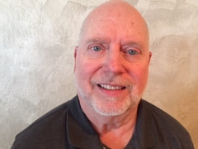

**Big Sir’s Salutations.**

**Dear fellow brothers of SIR,**

**On Friday, July 31st a federal appeals court threw out Boston Marathon Bomber Dzhokhar Tsarnaev’s death sentence. This was a shock to me since he had killed 3 people and wounded 240, but I guess nothing should shock me in today’s society. We just seemed to get hit with one negative after another!**

**I believe the negatives help us to understand why the positives of SIR are so important. Golf has been a blessing to me and the friendships are a blessing to all of us.**

**We are continuing to encourage those friendships through “face to face” meetings. We will meet on August 24 at the Mormon Station in Genoa. The business meeting will start at 10:00AM and the general meeting will start at 11:00AM. The Mormon Station has tables but bring a comfortable chair, your drinks and your food if you so desire.**

**Please continue to keep a positive attitude as we go through these difficult times knowing that this too will pass.**

**Kind regards,**

**Jim 1.**

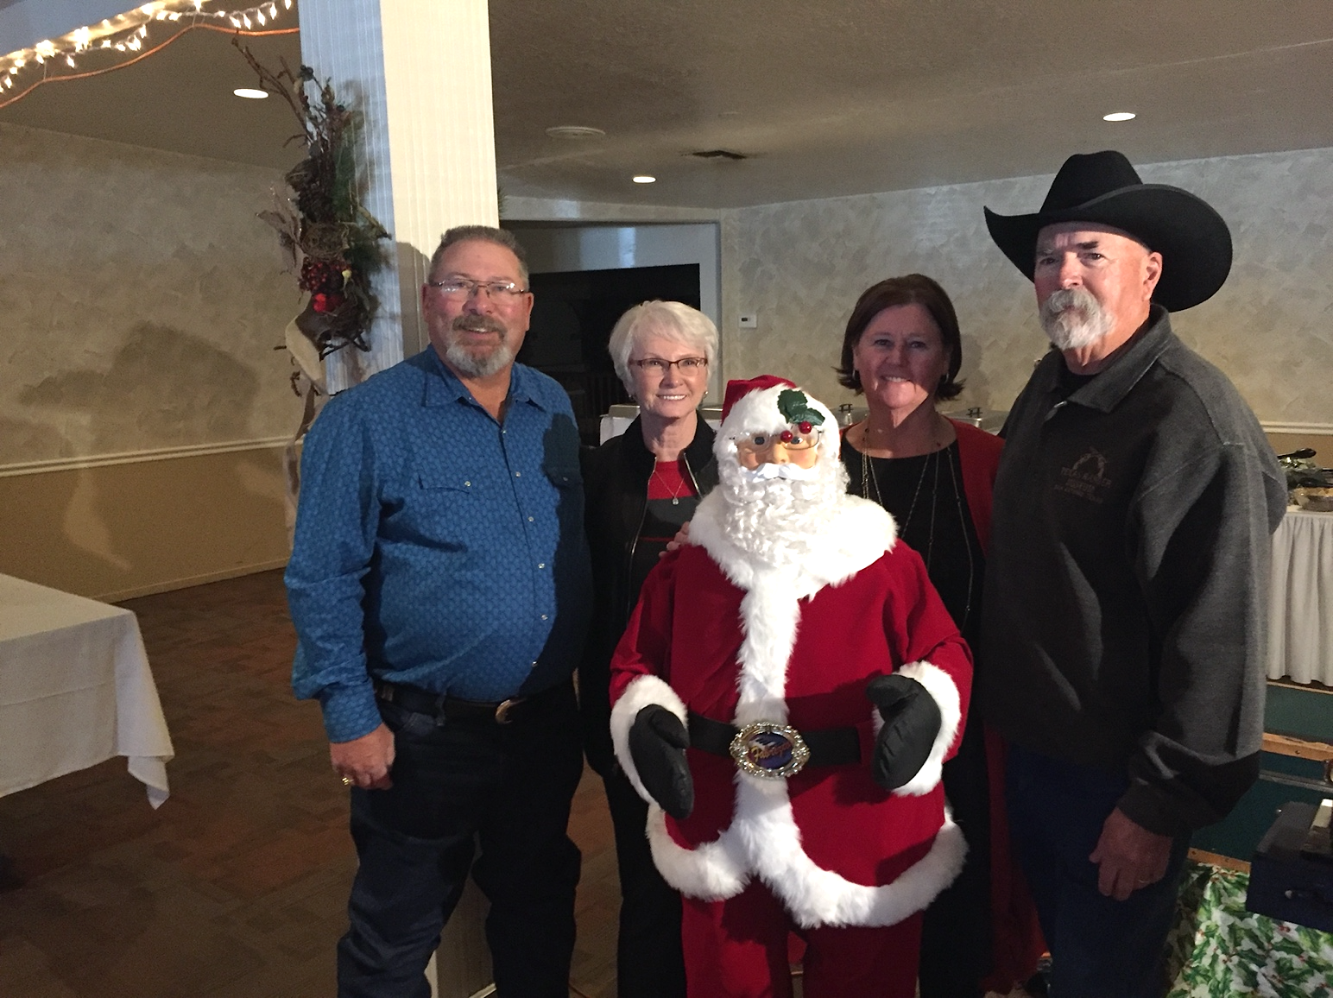

Little Sir Joe Tomlin

Well I hope this finds all our members and family doing well. I don’t have a lot to talk about this month. We will be having our monthly meeting at Mormon Station State Park in Genoa, on August 24th. Time will be business meeting starts at 10 AM and general meeting at 11 AM. If you attend please remember to bring your face mask. The ranger told me if you use the restroom you have to wear a mask. We are still limited to 50 people, hopefully this will all end soon.

If you can car pool that would be great because parking is limited. I also would like to thank Sig for putting on some great golfing tournaments, it’s been a good summer. Stay Safe

Thank You Little Sir Joe Tomlin

Sir Board Meeting Minutes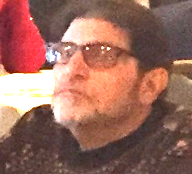

July 12, 2020

Call to order: The meeting was called to order at about 7:20 PM when a quorum was reached via ZOOM. Agenda and minutes from June 22 were approved.

Reports:  
**Big Sir:**  Jim Beilstein reported he was excited to be adding new people.

**Little Sir:** Joe Tomlin is looking for a possible head count for our picnic. He advised that the new date for the picnic will be September 28th.

**Treasurer:** John Lilygren was not available for a report.

**Secretary:** Gordon Salas wanted to make sure that the September 28th date was correct. The previous minutes advised that the date would be the 26th.

**Committee Reports:**

**Attendance:** Steve Butts advised that our attendance is now 94 and he has three applications in hand;  
Kip Steel, Phil King, Brad Thompson

**Bowling:** Per Tim Hall all tournaments are cancelled at this point.

**Golf:** It’s been reported that Sig wants to retire as head of golf.

**Newsletter:** Larry Coffman advised the latest newsletter has been sent out to all.

**Webmaster:** Our new webmaster Jim Maxedon has done a lot of work on our website. Check it out.

No other committee reports were given.

**Old Business:**  
We updated the tentative for the SIR picnic. It now stands at September 28th (pending lifting of Coronavirus restrictions and approval of State SIR).

**2.**

**New Business:**  
We voted and accepted the 3 new applicants into our SIR group. Neil Wolf was asked to be the new Secretary and declined. He indicated he would be honored to remain the Assistant Secretary.

Next meeting scheduled for August 24th at Mormon Station in Genoa.

Meeting adjourned at 8PM. Submitted by Neil Wolf

**_____________________________________________________________________________**

**~NOTICE~**

**All travel events and other activities sponsored by Sons In Retirement, Incorporated, or its Branches, are for the convenience and pleasure of its members and their guests who desire to participate. Sons In Retirement, Incorporated, and its Branches do not assume any responsibility for the well-being or safety of the participants or passengers, or their property or any damages whatsoever, in any manner pertaining to said activities.**

ROOSTER SALES

~NOTICE ON SALE NOW~

SUPPORT “The SIR” ~ DRESS IT UP WITH ROOSTER PINS,

HATS AND SHIRTS.

SHOW HOW PROUD YOU ARE TO BE A SIR!!

HATS ~$10

VESTS ~$29.50

POLO SHIRTS~ $16/$21

WICKING SHIRTS~$20/24/30

PINS ~ SMALL $2/LARGE $3

GOLF/BOWLING TOWELS ~$9

Start looking good!

DAVE TIONGCO

**3.**

**ROSTER CHANGES**

Welcome New members

Philip King 1406 Topaz Lane Gardnerville, NV 89460 775-690-3731 Badge #42 [Pil.Sri41@gmail.com](mailto:Pil.Sri41@gmail.com)

Brad Thompson, Badge # 64, Spouse Shani,

683 Marion Way Gardnerville, NV 89460

530-318-8575 [Brad912E@gmail.com](mailto:Brad912E@gmail.com)

Kip Steele, Badge # 20, Spouse Mary, 998 Edna Drive Gardnerville, NV 89460

775-265-8888 [SteeleKR@charter.net](mailto:SteeleKR@charter.net)



**MEMBERS ANNIVERSERY**

**FOR THE MONTH OF AUGUST**

**2004 Mike Vadnais, 2005 Richard Gwinn, 2006 Dave Tiongco, 2007 Skip Hempler, 2008   
Russ Dow, 2009 Tom Sawyer, 2016 Dennis Wingate, 2017 Jiom Beilstein, Joseph D’Angelo, Lee Edwards, Joe Tomlin, 2019 Neil Fox, Steve Holstrom, Randy Ramociotti and Ed Waggoner**

**SUNSHINE REPORT**

**Our Sunshine Chairman is Mike Vadnais. His phone number is 775-546- 0810. Let Mike know if someone is under the weather or if a family member is not well.**



AUGUST BIRTHDAY BOYS

***Dale Friend, Dave Tiongco, Steve Holstrom, Marshall McCurdy, Ken Koegl, Bill Kudenov, Karl Keller, and Sig Heidemann***

HAPPY BIRTHDAY SIRS

***Previews of Coming Attractions …***



AUGUST/SEPTEMBER/OCTOBER

**24 AUG SIR MEETING Genoa Mormon Park’ 10am-business meeting 11am**

**25 AUG Golf Incline Village Mt Course 10am SG**

**31 AUG Golf Silver Oak 8:30am SG**

**8 SEP Golf Red Hawk 8:30am SG**

**14 SEP Golf Lake Tahoe G.C. 8:30am**

**21 SEP Golf Carson Valley 9:00 am SG**

**29 SEP Golf Sunridge 9:00 am SG**

**5 OCT Genoa Ranch 9:00 am SG**

**26 SEP SIR MEETING**

**12 OCT Dayton Valley 9:00 am SG**

**4.**

**How to sponsor a New Member. . .**

**He should be able to attend the monthly meetings. Make him aware that there is an assessment of $6 once a year, but some members make voluntary donations to help cover our expenses. Tell Him that dress is casual and to arrive at Tep’s Villa Roma during the social hour - -after 11a.m. but well be for 12 noon –Introduce your guest as a prospective member when called upon. He won’t have to make a speech. Pick up an application. Help him fill it out and then return it to the Membership Chairman. His application will be processed and, typically, he can be introduced as a New Member at our next regular luncheon meeting.**

***ATTENDANCE REMINDER***

Sir’s if you plan to (1) miss more than 3 meetings in a row, or (2) if you need to be put on Medical Leave as a patient or caregiver, or (3) if you are leaving the area either as a snowbird or for an extended vacation. Please contact Steve Butts at (775)722-0177 or email at [Stakas94@att.net](mailto:Stakas94@att.net). Members will be contacted if they are missing meetings without notification.

Visit the SIR Website at sirinc.org and read “SIR HAPPENINGS”—the SIR State Newsletter. Sir Branch 160 Web Site is up and running. <https://sirinc2.org/z_branch160/index.html>

**DON’T ASK ME TO VOLUNTEER!**

**I’d like to belong to your Organization –**

**I’m willing to pay the dues.**

**I’ll come to the meeting, devour the lunches**

**But ask me to work?.......you’ll lose!**

**I’m fond of Golf, Bowling**

**and parties,**

**I’ll come to all those with good cheer**

**But serve on committees**

**Ah NO, I cannot volunteer!**

**You see.....**

**My wife’s cat had kittens**

**My dog has the measles**

**And I hurt my leg last year getting out of a golf cart!**

**So I’m not in condition**

**To volunteer**

**PLEASE don’t ask me to volunteer.**

**5.**

Membership & Luncheon Report

Sons In Retirement – Lake Tahoe Branch 160

Your attendance Chairman, Steve Butts

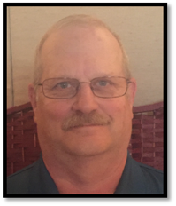

JULY 2020

Members Dropped (0)

Members Added (3) Philip King, Brad Thompson, Kip Steele

Inactive to active (0)

Medical Leave (7) Ed Rector, Jack Post, Franz Goepfert, John Gooding, Ron Thompson, Joe McKenna, and Van Marshall

Excused Snow Bird (0)

Total excused members (7)

Total number unexcused (0)

Total Member previous report (94)

Total Members this report (97)

Net active members (90)

Attendance BEC meeting– active members (9)

Zoom meeting

Visitors-(0)

Speaker (0)

Total present (9)

…NEWSLETTER…

**LAKE TAHOE BRANCH 160 EXECUTIVE COMMITTEE**

**BIG SIR------------------------JIM BEILSTEIN-----------------775-790-5180 DIRECTOR----------------LARRY COFFMAN---------------530-577-0328**

**LITTLE SIR-------------------.JOE TOMLIN--------------------775-790-7160 DIRECTOR--------------- SKIP HEMPLER-------------------775-588-4998**

**SECRETARY-----------------GORDON SALAS--------------775-690-2026 DIRECTOR---------------TERRY CANNON------------------775-883-4605**

**ASST. SECRETARY--------NEIL WOLF----------------------530-577-0818 DIRECTOR----------------GEORGE RAMIREZ-------------530-541-0641**

**TREASURER----------------JOHN LILYGREN---------------530-577-5234 DIRECTOR----------------JOHN GERARD-------------------530-542-2876**

**ASST. TREASURER-------VERN FLICKLIN----------------530-600-0918 DIRECTOR----------------STEVE BUTTS---------------------775-722-0177**

**HONORARY DIRECTORS**

**KEN KOEGL----------------------------------619-651-5508 MIKE VADNAIS------------------------------------775-546-0810**

**JACK POST-----------------------------------530-570-8063 DAVE TIONGCO-----------------------------------775-265-9448**

**TOM SAWYER-------------------------------775-852-8675 RON THOMPSON----------------------------------775-848-1402**

**VAN MARSHALL----------------------------530-307-0786**

BRANCH OFFICIAL E-MAIL CONTACT AND WEB MASTER JAMES MAXEDON jmx7@pacbell.net

Area 6 Governor – Gary Johnson 530-333-4814 - Region 2 Director – Richard Kindle 209-652-608 - State President– Ed Benson

SIR Branch 160 Newsletter

P.O. Box 550086

So. Lake Tahoe, CA 96155



