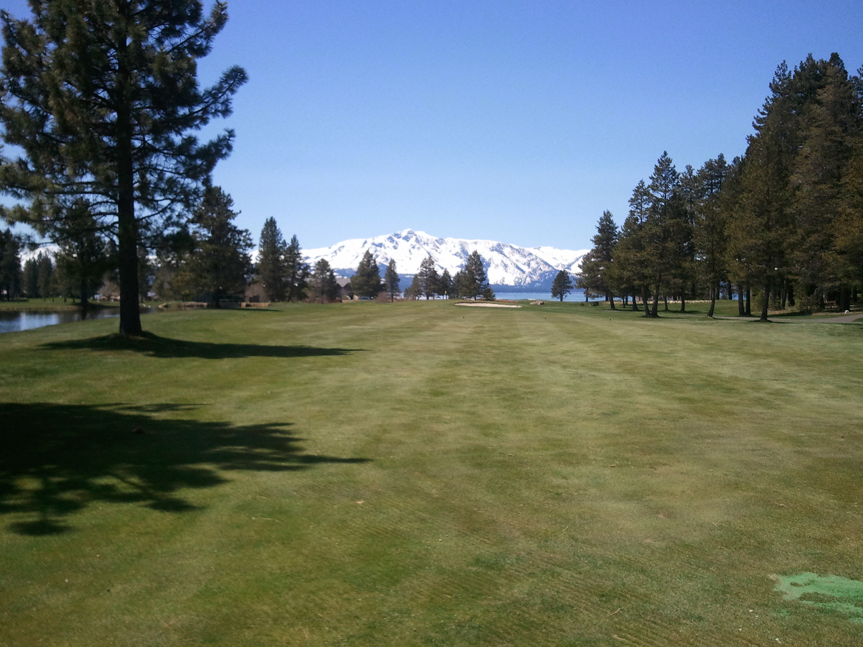

** ***“The SIR” ~ LAKE TAHOE BRANCH 160 ~*** **

***CHARTERED APRIL 22, 1991***

**MEMBERSHIIP OPEN TO MEN REGARDLESS OF AGE, RACE, COLOR, OR RELIGION**

**GETTING TOGETHER FOR LUNCH AND ENJOYING OUR VARIOUS ACTIVITIES**

***HIGH MOUNTAIN NEWS***

**JULY 2020**

We meet the 4th Monday of the month

Next reg. meeting – our 356th …………JULY 27, 2020……….……………………We meet at Tep’s Villa Roma

Officers & Chairmen………………………10:00am.....................................................3450 Lake Tahoe Blvd (Hiway50)

Social hour…………………………………….11:00am……………………………………..South Lake Tahoe, California

Luncheon……………………………...............12:00noon…………………………………..Across from the Bijou Center

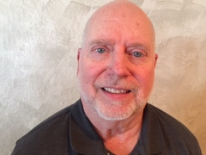Dear fellow brothers of SIR,

Our country has been through a difficult time the last few months. This really is poignant this month as we commemorate our independence as stated on the Liberty Bell in Philadelphia, “Proclaim liberty throughout all the land unto all the inhabitants thereof.” The founding fathers of the United States of America embraced the connection of freedom, family and property rights as they inscribed the Liberty Bell.

Even though some of our freedoms have been curtailed we can still celebrate our historic and continuing freedoms. In this vain, the executive committee voted to open all SIR Branch 160 activities starting on July 20th. This, of course, is contingent on meeting the restrictions of California and Nevada.

This reopening for golf is outlined in Sig Heidemann’s letter dated June 22, 2020. However, bowling is stilled closed until further notice per Tim Hall. Tim has led our outstanding bowling group for many years and is looking for someone to replace him in this leadership position.

The Executive Committee also voted to postponed our annual picnic until September 27th in hopes that the state restriction of 50 people will be rescinded.

**1.**

Larry Coffman has agreed to set up the virtual communications program Zoom so that we will be able to hold our monthly meetings through the internet. This will help us to continue to communicate.

As we celebrate our independence this month, I hope each of us will embrace how SIR can continue to be a positive force in our lives.

Kind regards, Jim

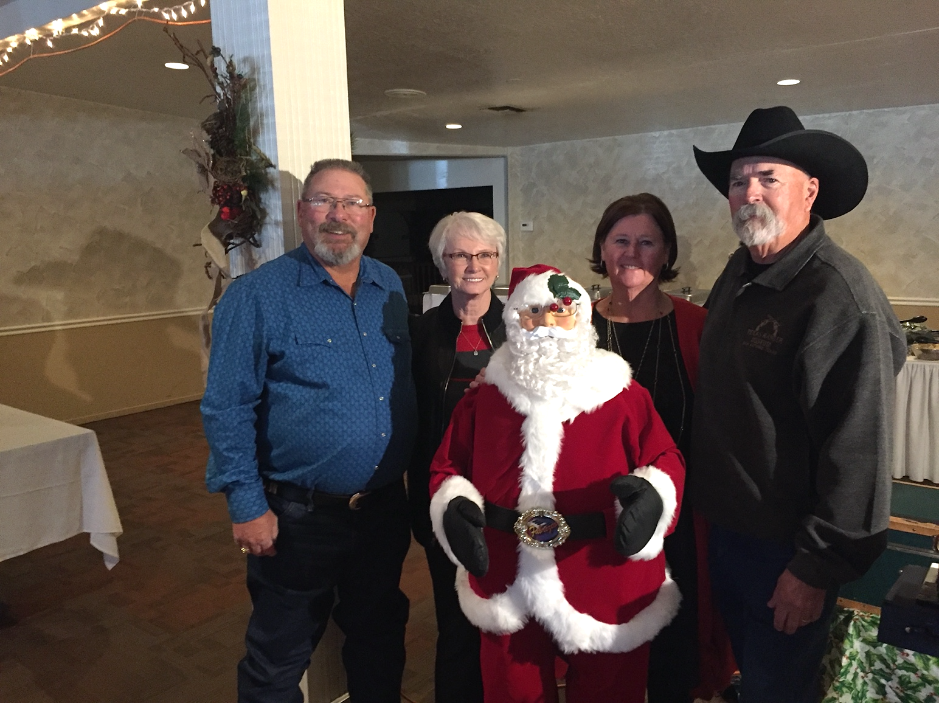

Little Sir Joe Tomlin

I hope this finds you and your family doing well in this crisis.

Let me begin with telling you about myself, I joined SIRS 3 years ago. I am a caller for list # 8, and also do the 50 – 50 raffles at our luncheons. I was asked to take Grayson Marshall place as Little Sir so here I am to tell you a little bit about myself, I am retired from the State of California, Dept. Of Transportation with 39 years’ service. My last 20 years I was a Caltrans Maintenance Supervisor in charge of all of hwy. 1 in Sonoma County. I also belonged to the blasting crew and rock scaling crew. So, I have been involved with a lot of exciting ventures.

I hope I can fill the shoes of the past Little Sirs; I will do my best. At this time, I don’t have any guest speakers lined up, not sure when our next meeting will be. I may be asking for some help from some of you with this task. I am looking forward to doing the best job I can as Little Sir.

Also, our annual July picnic has been cancelled and moved to September 28, 2020 at Lampe Park in Gardnerville, NV. I also belong to the Sirs golf team and having a great time. It’s a great bunch of guys. I also bowl at some of the Sirs bowling events.

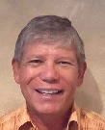Thank You Little Sir Joe Tomlin

June 22, 2020

SIR Board Meeting

Call to order:

The scheduled meeting for June was held at Tep’s Villa Roma Restaurant. Verifying that a quorum was present. Big SIR Jim Beilstein called the meeting to order at 12:08 p.m. Request for approval of the agenda was made and seconded. Request for approval of the February 24, 2020 meeting minutes was also made and seconded. All were approved.

**2.**

**Reports:**

**Big Sir:** Jim Beilstein informed to Board of the resignation of Little Sir Grayson Marshal. Joe Tomlin was voted on and unanimously approved as the new Little Sir. Big Sir said All Board members are required to go the State Web Site and review the ‘Fiduciary E-Mail prior to any reopening of Branch 160 can take place. The site can be found in the monthly news letter.

**Little Sir:** Sir Joe Tomlin said that he had been in contact with Carson City about the renting of Lampe Park for the 2020 summer picnic. A limit of not more than 50 people can attend due to the restrictions placed by local government because of the Corona Virus mandates. Little Sir Tomlin was going to get back into contact with the City of Carson pertaining to such restrictions and the limits of moving the date to late summer in hopes of the virus restrictions being lifted or less restrictive at a later date. Discussion of the Board was the if only 50 members could attend it would be best to cancel the picnic. More information is to come and will be shared at future meetings.

**Treasurer:** Sir John Lilygren reported that the SIR savings account has a balance of $ 4,000.32. Checking had a petty cash amount of $200.00.

**Secretary:** Sir Gordon Salas had nothing to report.

**Committee Reports:**

**Attendance:** Sir Steve Butts reported that Branch 160 has 107 members. However, given the loss of some members due to health-related issues the Branch is expected to be down to 97 active members by the next meeting.

**Bowling:** Sir Tim Hall was not present for the Board of Directors Meeting. Sir Sig Heidemann reported that bowling alleys in the Carson Valley are beginning to reopen and tournaments are taking place.

**Head Caller:** No report

**Winter Golf:** No report

**Golf:** Sir Sig Heidemann reported that Sir golf had to cancel the annual Plumas golf trip. He announced that all deposit money has been returned. Three of the scheduled weekly golf outings were cancelled due to the Corona Virus. Sig has written a letter to the Sir State Board to request the reopening of Branch 160 activities on July 20, 2020. The letter was read and it given to Big Sir Jim Beilstein to forward at his discretion.

**3.**

**Membership:** Sir Joe D’Angelo reported that he had two new applications for membership. The applicants will attend a meeting at the next available opportunity to be introduced to Branch 160.

**Newsletter:** Sir Larry Coffman requested that all information for the July newsletter be to him by July 7, 2020.

**Rooster Sales:** Sir Dave Tiongco reported that he has several new style of patriotic hats. They are styled in red, white and blue. This was brought about by members who had requested a patriot themed hat.

**Sunshine:** No report

**Web Master:** Sir Jim Maxedon (not present) was recognized by Big Sir Beilstein for the fine job he has done on Branch 160 News Letter. He encouraged all members to visit the site.

Old Business: The picnic is tentatively rescheduled for September 26, 2020. This date is dependent on the lifting of Corona Virus restrictions and approval of the State Sir.

**New Business:** Reopening possibly in July if approved by State Sir and Tep’s ability to host our gathering. Upcoming Board Member vacancies. Nominations needed for Secretary and Little Sir.

Meeting adjourned at 1:05 Submitted by Gordon Salas Secretary

SIR Lake Tahoe Branch 160 website update

Jim Maxedon June 22, 2020

Gentlemen,

I have been in contact with the State SIR web administrator and gained access to the SIR Lake Tahoe Branch 160 website. He has archived the old site and created a new site using WordPress publishing system. From that point I re-created the old site on the new site with a new look, theme, and navigation.

The first thing that I did was to replicate most of the information from the old site to the new site while using current officers, membership, and calendar information. So the new website is up to date.

The new website is here: <https://sirinc2.org/branch160/> For reference, the old site is here: <https://sirinc2.org/z_branch160/index.html>

As you can see, the new site is somewhat golf centric. That is most of the information I have as far as activities other than meetings is concerned. I do have the 2020 Bowling schedule. I can add more activities to the site if that information is available and useful.

**4.**

I have also created a “social media” space as a Facebook Group page. This is a place for interactions, posts, and comments among interested members. That page is located here: <https://www.facebook.com/groups/231849621520287/>

I’m open to suggestions for enhancing the site, so let me know if you have any. Any other comments are welcome of course.

Thanks for letting me help with this project!

Jim Maxedon – Webmaster 209-914-5669

|  |  |  |  |  |  |  |
| --- | --- | --- | --- | --- | --- | --- |
|  | **Branch** | **160** | **Golf Dates** | **2020** |  |  |
| **DATE** | **TEE TIME** | **GOLF COURSE** | **TOURNAMENT TYPE** | **LUNCH** | **PLAYERS** | **FEE** |
| 7/20/20 | 8:30 AM SG | SILVER OAK | 2 MAN – 1 BEST BALL |  | 40 | $43.00 |
| 7/28/20 Tues. | 8:30 AM SG | TOIYABE | 4 MAN – 1 BEST BALL | cof/don | 40 | $50.00 |
| 8/3/20 | 8:30 AM SG | GENOA LAKES | 4 MAN – 2 BETTER BALLS |  | 40 | $49.00 |
| 8/10/20 | 8:30 AM SG | WOLF RUN | 4 MAN – 1 BEST BALL |  | 40 | $50.00 |
| 8/17/20 | 8:30 AM SG | GENOA RANCH | HEIDEMANN CUP IND. STROKE PLAY |  | 40 | $45.00 |
| 8/25/20 Tues. | 10:00 AM SG | INCLINE VILLAGE (mtn) | 2 MAN – 1 BEST BALL |  | 32 | $50.00 |
| 8/31/20 | 8:30 AM SG | SILVER OAK | SIR CLUB CHAMPIONSHIP | YES | 44 | $50.00 |
| 8/3/20 | 8:30 AM SG | GENOA LAKES | IND. STROKE PLAY |  | 40 | $49.00 |
| 9/8/20 Tues. | 8:30 AM SG | RED HAWK (LAKES) | 4 MAN – MOD. SHAMBLE |  | 40 | $55.00 |
| 9/14/20 | 8:30 AM MSG | LAKE TAHOE G.C. | 4 MAN – 1 BEST BALL |  | 36 | $50.00 |
| 9/21/20 | 9:00 AM SG | CARSON VALLEY | IND. STROKE PLAY | HOTDOG* | 36 | $40.00 |
| 9/29/20 Tues.  10/5/20 | 9:00 AM SG  9:00 AM SG | SUNRIDGE  GENOA RANCH | 2 MAN – 1 BEST BALL | YES | 36  40 | $40.00  $45.00 |
| 7/13/20 | 9:00 AM TT | APPLE MOUNTAIN | 4 MAN – 1 BEST BALL |  | 24 | $36.00 |
| 10/12/20 | 9:00 AM SG | DAYTON VALLEY | 4 MAN MOD. SHAMBLE |  | 40 | $35.00 |

N NOTE: SG-SHOTGUN, TT-TEE TIME, MSG-MODIFIED SHOTGUN

1, SIGN UP ONE WEEK PRIOR FOR EACH TOURNAMENT BY EMAIL WITH GOLF CHAIRMAN.

2. PAY GREEN FEE AT EACH GOLF COURSE.

3. $5.00 PRIZE FUND TO BE COLLECTED BY DESIGNATED PERSON.

GOLF TOURNAMENT CHAIRMAN SIG HEIDEMANN, 775-265-4810, EMAIL sigheide@aol.com. ASST. GOLF CHAIRMAN TOM SAWYER, 775-852-8675, EMAIL tws@urn.edu. All tournaments are subject to change.

**5.**

What are my thoughts regarding the Branch 160 bowling program? At the present time they are very mixed. A major part of my recreational activities and social times are and have been altered or curtailed by the Covid-19 virus pandemic. I have been waiting to see what impact the opening of society as guided by our government leaders would bring forth before developing plans for our annual September tournament at Carson Lanes. I miss bowling and my bowling buddies, but I’m glad I waited. The results right now are nothing short of catastrophic for the American people due, in my opinion as a well-educated scientist, at least in large part to the politicization of the recovery process.

At present, I do not feel comfortable bringing together a large assembly of the country’s most vulnerable people – we, the elderly. I, as an eighty-year-old senior citizen, do not feel secure that people in particular who feel their freedom is compromised by wearing a mask will act responsibly to protect the health of others. And those who refuse to wear protective masks, both young and old, are everywhere! The physical layout of Carson Lanes is, unfortunately, not well designed to promote the recommended social distancing for personal protection.  Gold Dust West or Winks in Gardnerville are better suited for this. Once the epidemic is more under control, these two houses may be acceptable for hosting our tournament in the future.

I believe that Ray DiBasilio of the SIR State Bowling Committee is planning to hold the biggest of all the SIR tournaments at the Reno Stadium on August 10-12. At the Stadium there should be sufficient room and stringent regulatory conditions to keep SIR bowlers relatively safe. I will probably attend this tournament and see how the world’s new post-Covid reality is working for bowlers. In the meantime, I will continue to monitor the pandemic and hope that this nation is able to bring it under control and provide reasonable protection for our citizens. If this happens by the end of July, we might consider offering a down-sized version of our tournament at either Gold Dust West or Winks. If by that time the spread of the virus is still not contained, I might consider demanding my First Amendment rights and start yelling “fire” in theatres just to share that warped perception of freedom with those who refuse to wear masks or practice social distancing in order to protect the health of others.

Tim Hall

SIR Branch 160 Bowling Chair

**____________________________________________________________**

**~NOTICE~**

**All travel events and other activities sponsored by Sons In Retirement, Incorporated, or its Branches, are for the convenience and pleasure of its members and their guests who desire to participate. Sons In Retirement, Incorporated, and its Branches do not assume any responsibility for the well-being or safety of the participants or passengers, or their property or any damages whatsoever, in any manner pertaining to said activities.**

**6.**

In Memoriam

Our Hearts and Prayers go out to

Will Twining’s and Jim LaPorts families and friends on their passing this past April

[](http://www.faithclipart.com/image/shining-angel-from-heaven.html)

Membership & Luncheon Report

Sons In Retirement – Lake Tahoe Branch 160

Your attendance Chairman, Steve Butts

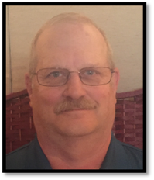

JUNE 2020

Members Dropped (13) Will Twining (passed) Jim LaPort (passed) Rudy Hammond, Grayson Marshall, William Fagliano, Jerry Beauchamp, Bill Kaster, Gordon Morrison, Dennis hillyard, John Benkert, Dan Gordon, Les Patterson, and Fran Reynolds

Members Added (0)

Inactive to active (0)

Medical Leave (7) Ed Rector, Jack Post, Franz Goepfert, John Gooding, Ron Thompson, Joe McKenna, and Van Marshall

Excused Snow Bird (0)

Total excused members (7)

Total number unexcused (0)

Total Member previous report (107)

Total Members this report (94)

Net active members (87)

Attendance BEC meeting– active members (12)

Visitors-(0)

Speaker (0)

Total present (12)

ROOSTER SALES

~NOTICE ON SALE NOW~

SUPPORT “The SIR” ~ DRESS IT UP WITH ROOSTER PINS,

HATS AND SHIRTS.

SHOW HOW PROUD YOU ARE TO BE A SIR!!

HATS ~$10

VESTS ~$29.50

POLO SHIRTS~ $16/$21

WICKING SHIRTS~$20/24/30

PINS ~ SMALL $2/LARGE $3

GOLF/BOWLING TOWELS ~$9

Start looking good!

DAVE TIONGCO

**SUNSHINE REPORT**

**Our Sunshine Chairman is Mike Vadnais. His phone number is 775-546- 0810. Let Mike know if someone is under the weather or if a family member is not well.**

Visit the SIR Website at sirinc.org and read “SIR HAPPENINGS”—the SIR State Newsletter. Sir Branch 160 Web Site is up and running. <https://sirinc2.org/z_branch160/index.html>

**7.**

…NEWSLETTER…

**LAKE TAHOE BRANCH 160 EXECUTIVE COMMITTEE**

**BIG SIR------------------------JIM BEILSTEIN-----------------775-790-5180 DIRECTOR----------------LARRY COFFMAN---------------530-577-0328**

**LITTLE SIR-------------------.JOE TOMLIN--------------------775-790-7160 DIRECTOR--------------- SKIP HEMPLER-------------------775-588-4998**

**SECRETARY-----------------GORDON SALAS--------------775-690-2026 DIRECTOR---------------TERRY CANNON------------------775-883-4605**

**ASST. SECRETARY--------NEIL WOLF----------------------530-577-0818 DIRECTOR----------------GEORGE RAMIREZ-------------530-541-0641**

**TREASURER----------------JOHN LILYGREN---------------530-577-5234 DIRECTOR----------------JOHN GERARD-------------------530-542-2876**

**ASST. TREASURER-------VERN FLICKLIN----------------530-600-0918 DIRECTOR----------------STEVE BUTTS---------------------775-359-6274**

**HONORARY DIRECTORS**

**KEN KOEGL----------------------------------619-651-5508 MIKE VADNAIS------------------------------------775-546-0810**

**JACK POST-----------------------------------530-570-8063 DAVE TIONGCO-----------------------------------775-265-9448**

**TOM SAWYER-------------------------------775-852-8675 RON THOMPSON----------------------------------775-848-1402**

**VAN MARSHALL----------------------------530-307-0786**

BRANCH OFFICIAL E-MAIL CONTACT AND WEB MASTER JAMES MAXEDON jmx7@pacbell.net

Area 6 Governor – Gary Johnson 530-333-4814 - Region 2 Director – Richard Kindle 209-652-608 - State President– Ed Benson

SIR Branch 160 Newsletter

P.O. Box 550086

So. Lake Tahoe, CA 96155



