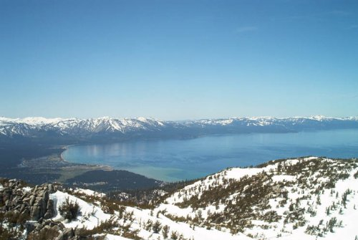**/**

** ***“The SIR” ~ LAKE TAHOE BRANCH 160 ~*** **

***CHARTERED APRIL 22, 1991***

**MEMBERSHIIP OPEN TO MEN REGARDLESS OF AGE, RACE, COLOR, OR RELIGION**

**GETTING TOGETHER FOR LUNCH AND ENJOYING OUR VARIOUS ACTIVITIES**

***HIGH MOUNTAIN NEWS***

**FEBRUARY 2020**

We meet the 4th Monday of the month

Next reg. meeting – our 353RD…………FEBRUARY 24, 2020……….…………We meet at Tep’s Villa Roma

Officers & Chairmen………………………10:00am.....................................................3450 Lake Tahoe Blvd (Hiway50)

Social hour…………………………………….11:00am……………………………………..South Lake Tahoe, California

Luncheon……………………………...............12:00noon…………………………………..Across from the Bijou Center

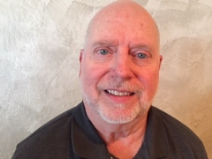**Big Sir’s Salutations**

**Dear fellow brothers of SIR,**

**I am sometimes asked about the wellbeing of someone in our SIR Brotherhood. When someone asks this question, it is with good intentions. But I should not share personal information about anyone without their permission.**

**We are family at SIR and it is important that we care for one another but we must always be careful that private information is guarded. A good rule of thumb is that when one of our brothers share something with me or you that is not public information, we should not share that information with anyone else without the permission of that brother**

**I know this is difficult for all of us and please talk to me about this subject if you have any concerns.**

**See you at the meeting.**

**God’s blessings,**

**Jim**

**1.**

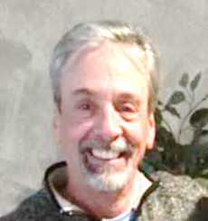Little Sir Grayson Marshall

In case you don’t know Little Sir Grayson. I am retired from the Transportation Planning and Engineering field. I have been a member of SIR for about two years. I currently reside in the Southwest Reno area. I enjoy playing golf, mountain biking, snow skiing and RVing. I look forward to recruiting interesting and fun speakers. Any assistance is greatly appreciated.

Next month speaker is David Borges a local D.C. in Tahoe who has spoken at previous meetings. The subject matter is on Tahoe history and can best described in Dave’s own words.

Grayson

***DATE CHANGES FOR BRANCH 160 MEETINGS FOR THE YEAR 2020.***

***Mark your calendars***



***MAY 18, 2020 Meeting Teps’***

***JULY 27, 2020 Branch picnic***

***OCTIBER 19,2020 Meeting Teps’***

***NOVEMBER 16, 2020 Meeting Teps’***

***DECEMBER 14, 2020 Christmas Luncheon***

**2.**

January 27, 2020

Sir Board of Directors Meeting

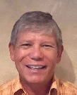

Call to order

The scheduled January meeting of Sir was held at Tep’s Villa Roma restaurant. It was determined that a quorum was present. Big SIR Jim Beilstein called the meeting to order at 10:02 a.m.

Reports:

**Big Sir:** Jim Beilstein opened the meeting by asking for approval of the agenda of the previous meeting. A motion was made, seconded and approved. He then asked for approval of the minutes. A motion was made, seconded and the minutes were approved. Joe Tomlin will be the new 50/50 person. Jim Maxedon will be the new Web-Master. Both of these positions were formally held by and made vacant by the recent passing of Mike Davis. Jim also pointed out that Jim Laporte was resigning as one of our callers. Ken Kogel is looking for a replacement.

**Little Sir:** Grayson Marshall was not present.

**Treasurer:** John Lilygren reported that was working on doing the annual audit.

**Secretary:** No report

Committee Reports:

**Attendance:** Steve Butts reported that Lake Tahoe Sir has 110 members. However, we did lose two members is recent weeks. He is formulating a letter to be sent out to several members who haven’t responded or answered emails pertaining to their participation in the club. Steve Butts reiterated that he was looking for another caller.

**Bowling:** Tim Hall, no report.

**Head Caller:** No report

**Winter Golf:** Gordon Salas announced that our Sir group would be playing Empire Ranch on Tuesday 1/28.

**Golf:** Sig Heidemann asked for approval of the 2020 summer golf schedule. A motion was made and seconded. Motion passed. He also stated that there is a cash balance in the golf fund of $2,853.66. However, a large portion of this amount was to be paid to the USGA handicap program for annual membership. He’s awaiting their bill.

**Membership:** Joe D Angelo said he didn’t have any new applications at this time.

**Newsletter:** Larry Coffman reviewed 2020 calendar to see what interest there is in attending a Reno Aces Baseball game. Last year’s event was very enjoyable.

**Rooster Sales:** Dave Tiongco said that he had catalogs for jackets and other assorted apparel.

**3.**

**Sunshine:** Steve Butts reported on behalf of Mike Vadnais that cards were sent out to Mike Davis’ family, Ron Rehman’s wife and Tim Donnelly.

**Web Master:** A motion was made to accept Jim Maxedon as Web Master. Motion was accepted and voted on unanimously.

**Old Business:**

Skip Hempler reported that he had acquired a carry case for the projector.

**New Business:**

Larry Coffman is looking at May for a Reno Aces Baseball outing. Perhaps a weekend. He will put it in the newsletter and send out group emails.

Adjourned: 10:56 Submitted by Gordon Salas Secretary

***ATTENDANCE REMINDER***

Sir’s if you plan to (1) miss more than 3 meetings in a row, or (2) if you need to be put on **Medi5.cal** Leave as a patient or caregiver, or (3) if you are leaving the area either as a snowbird or for an extended vacation. Please contact Steve Butts at (775)722-0177 or email at [Stakas94@att.net](mailto:Stakas94@att.net). Members will be contacted if they are missing meetings without notification

***These are the dates for Reno Aces Baseball games for May. Pick a date that works for you and let me know. Whichever date gets the most action that will be the date I will make reservations for.***

***Larry C. userramp@aol.com***

***May 9 Sat. 4:05 start vs Fresno***

***May 10 Sun 1:05 start vs Fresno***

***May 16 Sat. 4:04 Start vs Las Vegas***

***May 17 Sun. 1:05 Start vs Las Vegas***

***May 19 Wed. 12:05 Start vs Las Vegas***

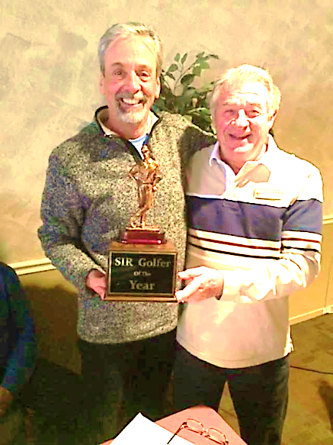

***Golf Chairman Sig Heidemann***

***on right presents the Branch 160 most improved golfer trophy for 2019 to Little Sir Grayson Marshall.***

***Congratulations Grayson***

**4.**

Membership & Luncheon Report

Sons In Retirement – Lake Tahoe Branch 160

Your attendance Chairman, Steve Butts

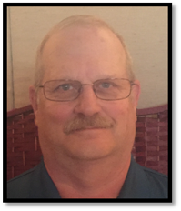

JANUARY 2020

Members Dropped (1) B. G. DAVES

Members Added (0)

Inactive to active (0)

Medical Leave (10) Ed Rector, Will Twining, Russ Dow, Jack Post, Jim LaPorte, Les Patterson, Frank Reynolds, Dan Gordon, Alan Norton and Franz Goepfert

Excused Snow Bird (16) Rudy Hammond, Jim Sand, Larry Tinker, Ken Koegl, Mike Parapid, Joe Carmona, Dick Scott, Dennis Wingate, Bill Van Hoosan, Dale Friend, William Fagliano, Marshall McCurdy, Neil Fox, Ed Waggoner, David Best, and Jerry Beauchamp

Total inactive members (26)

Total number unexcused (29)

Total Member previous report (108)

Total Members this report (107)

Net active members (81)

Attendance – active members (52)

Visitors-(0)

Speaker Br 160 Member Bruce Steger

Total present (52)

|  |
| --- |
|  |



BADGE DRAWING WINNER FOR

FEBRUARY LUNCHEON

BRUCE STEGER

**Come to a meeting, have lunch, hear our guest speaker and have your badge pulled from the bucket for a lunch on the SIR at the next meeting.**

**~NOTICE~**

**All travel events and other activities sponsored by Sons In Retirement, Incorporated, or its Branches, are for the convenience and pleasure of its members and their guests who desire to participate. Sons In Retirement, Incorporated, and its Branches do not assume any responsibility for the well-being or safety of the participants or passengers, or their property or any damages whatsoever, in any manner pertaining to said activities.**



**MEMBERS ANNIVERSERY**

**FOR THE MONTH OF FEBRUARY**

**2003 Curt Emrie, 2016 Bruce Steger, 2017 Michael Parapid, Karl Johnson**

**5.**

**The following Sirs please attend a meeting and pay your $6 annual assessment or email to John Lilygren. John Benkert, Ed Bludau, Bill Fagliano, Franz Goepfert, Rudy Hammond, Dennis Hillyard, Bill Kaster, Van Marshall, Les Patterson, Jack post, Frank Reynolds and Kurt Schanz**

**Lake Tahoe Branch 160 Badge Color Scheme**

**Charter Member…RED Honorary Life**

**Member… GOLD New Member…BLUE the rest of us…BLACK. When you see a badge with BLUE lettering indicating a NEWER MEMBER, be sure to make him feel welcome.**

ROOSTER SALES

~NOTICE ON SALE NOW~

SUPPORT “The SIR” ~ DRESS IT UP WITH ROOSTER PINS,

HATS AND SHIRTS.

SHOW HOW PROUD YOU ARE TO BE A SIR!!

HATS ~$10

VESTS ~$29.50

POLO SHIRTS~ $16/$21

WICKING SHIRTS~$20/24/30

PINS ~ SMALL $2/LARGE $3

GOLF/BOWLING TOWELS ~$9

Start looking good!

DAVE TIONGCO

**6.**

***Previews of Coming Attractions …***

 **FEBRUARY**

**CHECK IN WITH GORDON SALAS FOR GOLF AND FOR BOWLING CHECK WITH TIM HALL**

**FEBRUARY 21 BOWLING**

**GOLD DUST LANES C.C. 11am**

**FEBRUARY 24 SIR MEETING**

**AT TEPS 12 noon**

**FEBRUARY 28 BOWLING**

**GOLD DUST LANES C.C. 11am**



HAPPY BIRTHDAY SIRS

**FEBRUARY**

**Grayson Marshall, Alan Norton, Wayne Feletar, Gordon Salas, Joseph D’Angelo, Michael Boecher**

In Memoriam

[](http://www.faithclipart.com/image/shining-angel-from-heaven.html)Our Hearts and Prayers go out to Russ Dow on the passing of his wife Stacy.

|  |  |  |  |  |  |  |
| --- | --- | --- | --- | --- | --- | --- |
|  |  | BRANCH 160 GOLF SCHEDULE 2020 |  |  |  |  |
| **DATE** | **TEE TIME** | **GOLF COURSE** | **TOURNAMENT TYPE** | **LUNCH** | **PLAYERS** | **FEE** |
| 3/30/20 | 9:00 AM SG | EAGLE VALLEY EAST | IND. STROKE PLAY | YES | 40 | $35.00 |
| 4/6/20 | 9:00 AM SG | EAGLE VALLEY WEST | 4 MAN – 1 BEST BALL | YES | 40 | $40.00 |
| 4/13/20 | 9:00 AM SG | SUNRIDGE | 4 MAN - MOD. SHAMBLE | YES | 36 | $40.00 |
| 4/20/20 | 9:00 AM SG | CARSON VALLEY | 4 MAN 2 BETTER BALLS | HOTDOG* | 36 | $40.00 |
| 4/28/20 Tues. | 9:00 AM SG | EMPIRE RANCH | 2 MAN – 1 BEST BALL | YES | 40 | $35.00 |
| 5/4/20 | 8:00 AM SG | SILVER OAK | IND. STROKE PLAY |  | 40 | $43.00 |
| 5/11/20 | 8:30 AM SG | GENOA RANCH | 4 MAN – 1 BEST BALL |  | 40 | $45.00 |
| 5/19/20 Tues. | 9:00 AM SG | TOIYABE | 4 MAN – 2 BETTER BALLS | cof/don | 40 | $50.00 |
| 5/26/20 Tues. | 8:30 AM SG | LAKERIDGE | 4 MAN – 1 BEST BALL |  | 40 | $55.00 |
| 6/1/20 | 8:30 AM SG | WOLF RUN | 4 MAN – MOD. SHAMBLE |  | 40 | $50.00 |
| 6/8/20 | 12:00 PM SG | PLUMAS | 4 MAN – 1 BEST BALL | DINNER | 28 | $440.00 |
| 6/9/20 | 8:36 AM TT | GRAEAGLE | 4 MAN – MOD. SHAMBLE | DINNER | 28 |  |
| 6/10/20 | 9:00 AM SG | PLUMAS | 4 MAN SCRAMBLE |  | 28 |  |
| 6/15/20 | 8:30 AM SG | GENOA LAKES | 2 MAN – 1 BEST BALL |  | 40 | $49.00 |
| 6/23/20 Tues. | 8:30 AM SG | DAYTON VALLEY | 4 MAN 2 BETTER BALLS | YES | 40 | $45.00 |
| 6/29/20 | 9:30 AM SG | MACE MEADOWS | 4 MAN – 1 BEST BALL |  | 24 | $30.00 |
| 7/6/20 | 8:00 AM SG | EMPIRE RANCH | IND. STROKE PLAY | YES | 40 | $35.00 |
| 7/13/20 | 9:00 AM TT | APPLE MOUNTAIN | 4 MAN – 1 BEST BALL |  | 24 | $36.00 |
| 7/20/20 | 8:30 AM SG | SILVER OAK | 2 MAN – 1 BEST BALL |  | 40 | $43.00 |
| 7/28/20 Tues. | 8:30 AM SG | TOIYABE | 4 MAN – 1 BEST BALL | cof/don | 40 | $50.00 |
| 8/3/20 | 8:30 AM SG | GENOA LAKES | 4 MAN – 2 BETTER BALLS |  | 40 | $49.00 |
| 8/10/20 | 8:30 AM SG | WOLF RUN | 4 MAN – 1 BEST BALL |  | 40 | $50.00 |
| 8/17/20 | 8:30 AM SG | GENOA RANCH | HEIDEMANN CUP IND. STROKE PLAY |  | 40 | $45.00 |
| 8/25/20 Tues. | 10:00 AM SG | INCLINE VILLAGE (mtn) | 2 MAN – 1 BEST BALL |  | 32 | $50.00 |
| 8/31/20 | 8:30 AM SG | SILVER OAK | SIR CLUB CHAMPIONSHIP | YES | 44 | $50.00 |
| IND. STROKE PLAY |
| 9/8/20 Tues. | 8:30 AM SG | RED HAWK (LAKES) | 4 MAN – MOD. SHAMBLE |  | 40 | $55.00 |
| 9/14/20 | 8:30 AM MSG | LAKE TAHOE G.C. | 4 MAN – 1 BEST BALL |  | 36 | $50.00 |
| 9/21/20 | 9:00 AM SG | CARSON VALLEY | IND. STROKE PLAY | HOTDOG* | 36 | $40.00 |
| 9/29/20 Tues. | 9:00 AM SG | SUNRIDGE | 2 MAN – 1 BEST BALL | YES | 36 | $40.00 |
| 10/5/20 | 9:00 AM SG | GENOA RANCH | 4 MAN – 1 BEST BALL |  | 40 | $45.00 |
| 10/12/20 | 9:00 AM SG | DAYTON VALLEY | 4 MAN MOD. SHAMBLE |  | 40 | $35.00 |

NOTE: SG - SHOTGUN TT – TEE TIME MSG – MODIFIED SHOTGUN

1. SIGN UP ONE WEEK PRIOR FOR EACH TOURNAMENT BY EMAIL WITH GOLF TOURNAMENT CHAIRMAN
2. PAY GREEN FEE AT EACH GOLF TOURNAMENT. CHAIRMAN SIG HEIDEMAN 775-265-4810

(C)775-220-8603 - EMAIL [sigheide@aol.com](mailto:sigheide@aol.com) TOM SAWYER 775-852-8675 EMAIL [TWS@URN.EDU](mailto:TWS@URN.EDU)

1. $5.00 PRIZE FUND TO BE COLLECTED BY DESIGNATED PERSON

ALL TOURNAMENTS ARE SUBJECT TO CHANGE

NO DRINKS

**7.**

**Notes from Tim Hall, SIR Branch 160 Bowling Tournament Manager, Spring 2020**

Please note that SIR bowling tournaments are held throughout the year, but the local tournament season sponsored by our local Carson Country Bowling Association (CCUSBC) runs each year from October through the first part of April. **Support your local bowling houses and Association in 2020!**

Here is pertinent information about pending tournaments that might be of interest to you:

1. **Carson Country USBC 2020 Annual City Open Championship** will be held at Carson Lanes on Saturday February 22nd and Sunday March 23rd. The tournament consists of a four-person team, a doubles event, a singles event and all-events. The entry fee is $29. For information and entry forms, contact ccusbcnv.com or [alexzandra6957@yahoo.com](mailto:alexzandra6957@yahoo.com). .
2. **SIR Area 16 Bowling Tournament** held at Diablo Valley Lanes in Concord, California, on Tuesday March 17th and Wednesday March19th. This tournament is for SIRs and their guests and includes singles, doubles and all events. Applications can be found on the SIR web site (sirinc.org) or by contacting the Tournament Manager, SIR Dan Weller, at (925) 935-5510.
3. **Carson Country USBC 2019 Men’s Invitational Championship and Women’s City Tournament** are being held this year on Saturday March 14th and Sunday March 15th at Gold Dust West Bowling Center. This tournament consists of six (6) consecutive games bowled on a single pair of lanes with total pins deciding the winner. Applications can be found on the Association website: ccusbcnv.com.
4. **SIR Branch 113 “Over the Hill” in Nevada Tournament** at Gold Dust West Bowling Center in Carson City, Nevada, is scheduled for Monday through Thursday, April13th-16th. This tournament is for SIRs and their guests and includes singles, doubles, team and all events. Applications can be found on the SIR web site (sirinc.org) or by contacting the Tournament Manager (and my former Pollock Pines partner in crime), SIR Ray DiBasilio, at (530) 558-9727 or [rdibasilio@gmail.com](mailto:rdibasilio@gmail.com). Sign up today! This is a very popular tournament and some squads may have already filled! I recommend giving Ray a call to find out which squads are still available! **Branch 160 bowlers** – this is our tournament to win and show Ray that being “over the hill” is a good thing!!
5. **Joint SIR Branch 96 and Branch 113 Bowling Tournament** at Gold Country Lanes in Sutter Creek, California, on Thursday June 11th and Saturday June 12th. This tournament is for SIRs and their guests and includes singles, doubles and all events. Applications can be found on the SIR web site (sirinc.org) or by contacting one of the Tournament Managers, SIR Ray DiBasilio, at (530) 558-9727 or [rdibasilio@gmail.com](mailto:rdibasilio@gmail.com); or SIR Emil Leese at (209) 296-3151 or [emileese@outlook.com](mailto:emileese@outlook.com).
6. Don’t forget SIR no-tap bowling, (Monte Carlo format) at **Gold Dust West** everyFriday of the month @ 11:00 AM!Bowl well and/or get lucky with cards and collect $$$.

BOWL ON!

**8.**

***Sir Branch 160 Officers for 2020***

***Big Sir Jim Beilstein***



***Little Sir***

***Grayson Marshall***

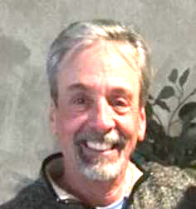

***Secretary Gordon Salas***



***Treasure John Lilygren***

***Director Larry Coffman***

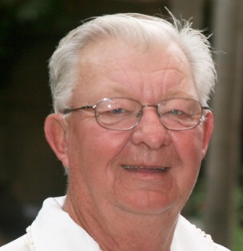

***Director Skip Hempler***



***Director Steve Butts***

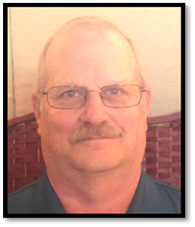

**9.**

***Director George Ramirez***



***Director Terry Cannon***



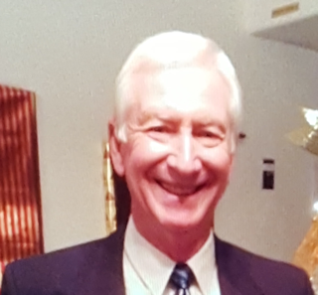***Director John Gerard***

…NEWSLETTER…

**LAKE TAHOE BRANCH 160 EXECUTIVE COMMITTEE**

**BIG SIR------------------------JIM BEILSTEIN-----------------775-790-5180 DIRECTOR----------------LARRY COFFMAN---------------530-577-0328**

**LITTLE SIR-------------------GRAYSON MARHALL--------530-368-1444 DIRECTOR--------------- SKIP HEMPLER-------------------775-588-4998**

**SECRETARY-----------------GORDON SALAS--------------775-690-2026 DIRECTOR---------------TERRY CANNON------------------775-883-4605**

**ASST. SECRETARY--------NEIL WOLF----------------------530-577-0818 DIRECTOR----------------GEORGE RAMIREZ-------------530-541-0641**

**TREASURER----------------JOHN LILYGREN---------------530-577-5234 DIRECTOR----------------JOHN GERARD-------------------530-542-2876**

**ASST. TREASURER-------VERN FLICKLIN----------------530-600-0918 DIRECTOR----------------STEVE BUTTS---------------------775-359-6274**

**HONORARY DIRECTORS**

**KEN KOEGL----------------------------------619-651-5508 MIKE VADNAIS------------------------------------775-546-0810**

**JACK POST-----------------------------------530-570-8063 DAVE TIONGCO-----------------------------------775-265-9448**

**TOM SAWYER-------------------------------775-852-8675 RON THOMPSON----------------------------------775-848-1402**

**VAN MARSHALL----------------------------530-307-0786**

BRANCH OFFICIAL E-MAIL CONTACT AND WEB MASTER JAMES MAXEDON jmx7@pacbell.net

Area 6 Governor – Gary Johnson 530-333-4814 - Region 2 Director – Richard Kindle 209-652-608 - State President– Ed Benson

SIR Branch 160 Newsletter

P.O. Box 550086

So. Lake Tahoe, CA 96155



