What are some
OF THE OTHER FUN THINGS WE DO?

Besides the 18- and 9-Hole Golf, Fishing Group, Computer Group, and Book Swap...

We Do Dine-Outs

We Create Activities

Our Members Want

We Have Lots of Fun

What are some
Of the things we don’t do?

We Don’t Raise Money for Outside Projects.
We Don’t Have a Political Agenda.
We Don’t Have a Religious Orientation.
We Don’t Sell Light Bulbs or Anything Else.
We Don’t Have a Problem with Organizations That Do These Things, It’s Just That We Don’t.
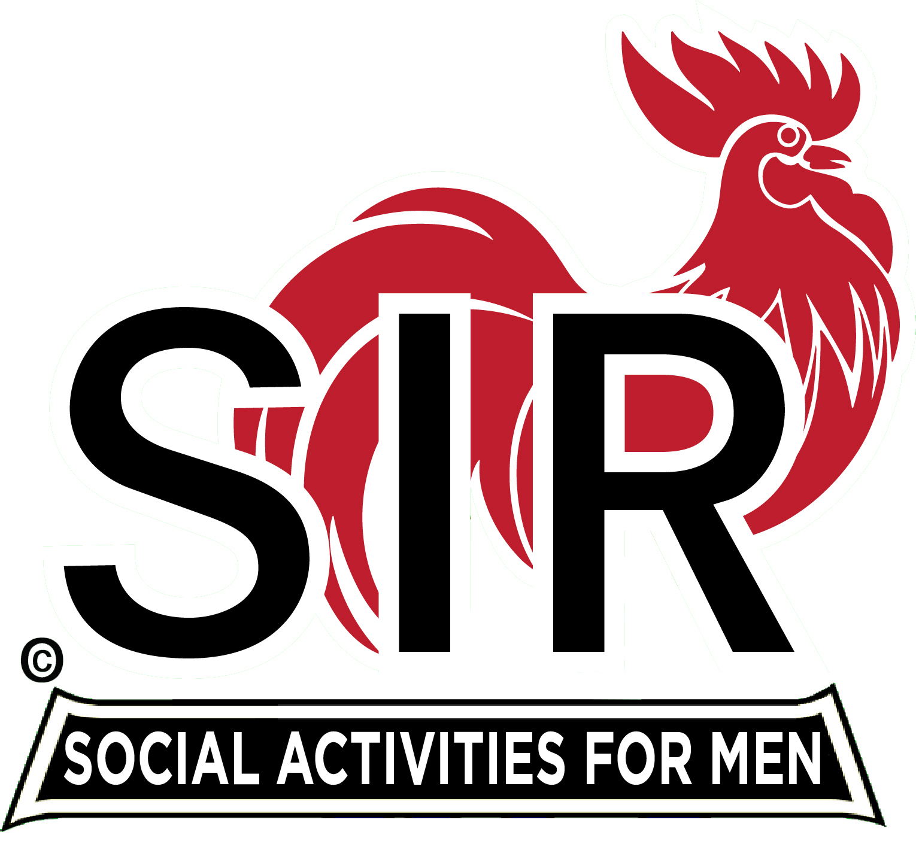
WHO ARE WE?
We are good fellows, men enjoying our free time with new friends and new activities.
(Sons In Retirement)

If you can come to our monthly meetings, you are eligible for membership in SIR. From its inception in 1958, SIR has grown to over 20,000 members statewide.

SIR Branch No. 129

We meet at the Elks Lodge in Redding for a Luncheon on the third Wednesday of the month starting at 11 a.m.
You are welcome!

For more information

Visit us online at…
http://sirinc2.org/branch129/.

http://www.sir129.org/




Want to make new friends and improve your life?

Take the next logical step:

Join SIR!

Make better use of your leisure time with like-minded men who are making new friends and enjoying new activities!

What are some
OF THE THINGS WE DO?

MEETINGS

Membership meetings are
held monthly where SIRs
gather for lunch to
socialize and renew
acquaintances. We have outstanding speakers who present a program of wide interest.


SPECIAL EVENTS
Several times during the
year, events are held to
which wives and friends are
invited: A Ladies Day Picnic.
A December Holiday luncheon, too! These activities are well attended by SIRs and their guests.
18-HOLE GOLF

An active golf program is a big part
of our activities. SIR golfers
enjoy local golfing and annual area-wide
tournaments at our finest courses.

FISHING
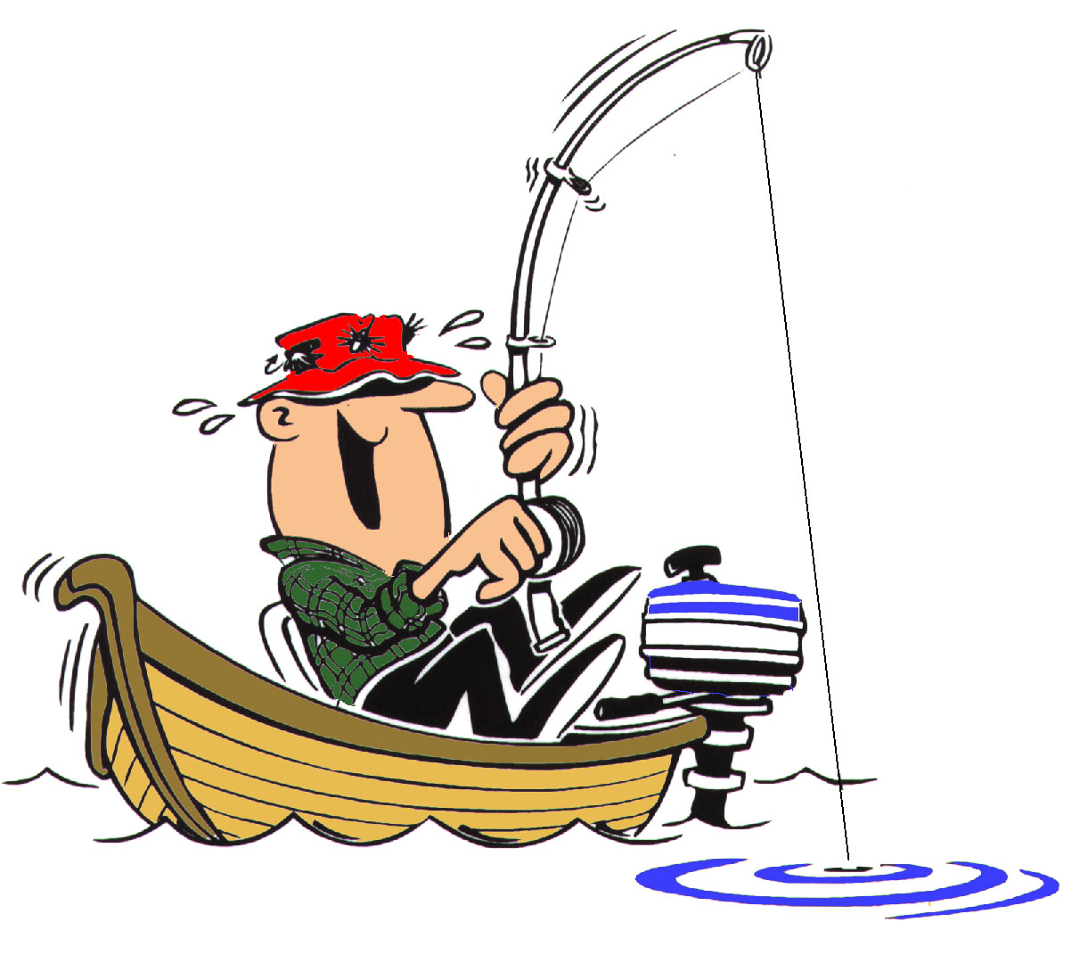
Northern California offers many
opportunities for fresh and salt
water fishing. Our fishing
group takes advantage of the lake and rivers in our area.
We have meetings to cover the ways we enjoy this sport.

COMPUTERS

Meetings are held regularly for
those interested in hardware
and software. The meetings
provide a useful forum
for the exchange of ideas and
learning about new
developments. Couples are
welcome, as are novices and experts.
9-HOLE GOLF
We also have an active 9- hole golf program that allows golfers to improve their short game and share in the comradery of golf while not having to walk all that much.

BOOK EXCHANGE
We also have a book exchange at our meetings so we can share the types of books we enjoy with others. You can browse and see if there is a book you want to read. Pick it up, take it home, and share your favorites next time!

For More Information

Turn the Page or
Email:
joesir2019@gmail.com
Subject: SIR Info…

